






Apprenticeship and final research internship report

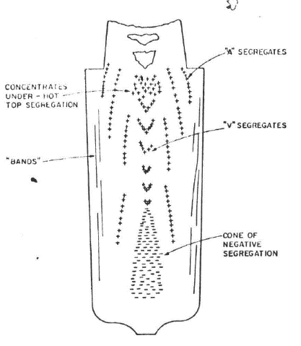
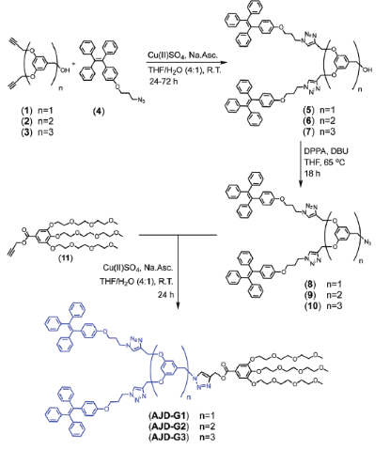

Corentin DARMANA
2020-2021 to 2022-2023

Ecole Européenne d’Ingénieurs en Génie des Matériaux,
Nancy

Apprenticeship supervisors (Framatome):
François ROCH, Laurent DE BAGLION DE LA DUFFERIE

Final research internship supervisors (NanoQAM, LCPM) :
Ali NAZEMI, Jean-Luc SIX

Remerciements
Merci à Arthur, François et tous les membres de la section DTIMMM pour l’accompagnement et l’encadrement tout au long de ces 3 années d’alternance chez Framatome, durant lesquelles j’ai tant appris.

Je remercie également Ali et Jean-Luc SIX pour ce stage qui a pu se dérouler dans les meilleures conditions, leur expertise et expérience me servent d’exemple. Il n’y aurait pas eu meilleure façon de renouer avec la chimie qu’en étant sous leur aile.
J’ai également pu compter sur l’aide et la bonne humeur quotidienne de Maryline, merci à toi pour cela et bon courage pour le reste de ta thèse.

Je dédie ce mémoire à ma mère et ma sœur qui, en ces 3 ans intenses de formation ingénieur, sont restées à mes côtés en permanence et m’ont soutenu malgré les longues périodes d’absences.

Résumé :
Ce rapport présente les travaux effectués lors de mon apprentissage chez Framatome à La Défense en tant qu’apprenti ingénieur métallurgiste, ainsi que ceux réalisés au laboratoire de chimie des matériaux « NanoQAM » de l’Université du Québec à Montréal lors de mon stage de fin d’études.
Mon sujet d’alternance chez Framatome était la solidification d’aciers péritectiques et peut se résumer en 3 axes distincts : les travaux technologiques, de recherche et de simulation.
Les travaux technologiques ont commencé par une synthèse des études liées au projet interne MOPPEC (Modélisation des Propriétés des Pièces ECrasées). Un bloom issu d’un lingot conventionnel a été caractérisé chimiquement. Cette cartographie en carbone, montrant de fortes hétérogénéités, servait de données d’entrée à un logiciel de simulation de forgeage. Ce dernier devait permettre de modéliser le devenir de ces zones « ségrégées » pendant différentes gammes de forgeage pour des pièces du réacteur nucléaire mais s’est révélé trop imprécis. J’ai également contribué à la capitalisation de données Framatome dans une base de données de simulation qui répertorie les traitements thermiques, les dimensions de lingot et d’ébauche, les taux de chutage, etc.
Les travaux de recherche se sont concentrés autour de la rédaction d’une bibliographie sur la microségrégation lors de la solidification des aciers dit « péritectiques ». Le but ici était de faire un état de l’art non exhaustif de la littérature à propos de cette thématique et de centraliser ces données dans un document interne Framatome. Ce document visait à expliquer les origines de la formation des microségrégations ainsi que les mécanismes de transport de matière impliqués, mais aussi de disséquer le mécanisme de la réaction péritectique.
Les travaux de simulation ont été organisés autour de Thermo-Calc. Ce logiciel permet de simuler une grande gamme d’étapes de fabrication de pièces de forge, et de suivre l’évolution de variables clés telles que les compositions chimiques ou bien les fractions de phases présentes. L’extension « DICTRA » permet d’approfondir la compréhension en prenant en compte les phénomènes de diffusion. Un mode d’emploi pour les nouveaux utilisateurs Framatome a été écrit et certains calculs d’illustrations ont été ajoutés. Le module « Propriétés des aciers » a été testé en vérifiant la précision des calculs de diagrammes de transformations à refroidissement continu (TRC) et en les comparant à ceux de la littérature Framatome. Ces derniers se sont révélés encore trop imprécis pour être utilisés à titre quantitatif.

Ma thématique de stage au sein de l’UQAM était la synthèse et caractérisation de dextranes modifiés par des dendrons de TPE (tetraphenylethylene).
Le dextrane est un polysaccharide naturel, biocompatible et biodégradable qui pourrait remplacer le polyéthylène glycol dans des applications biomédicales. Ce polymère a été greffé par des dendrimères de génération 0 et 1 contenant des groupements TPE. Ces derniers possèdent des propriétés de fluorescence et d’autoassemblage favorisé, mais aussi la propriété d’émission induite par agrégation. Cela veut dire que le TPE sous sa forme agrégée verra une augmentation de son intensité de fluorescence. Cet état agrégé peut-être atteint dans un solvant comme l’eau ou bien à forte concentration. Une réaction de chimie click a été employée pour la synthèse, la CuAAC (Copper Alkyne Azide Cycloaddition), pour ses caractéristiques de faible coût, haut rendement et respectueuse de l’environnement. Les dextranes ont été ramifiés avec des fonctions alcynes par l’équipe de Jean-Luc Six et une fonction azoture terminale a été ajoutée sur les dendrimères contenant des TPE afin de permettre le couplage.
La réaction pour le greffage du dendron G0 sur le dextrane a duré 24h, et le produit était suffisamment pur après 2 précipitations dans l’isopropanol et le DMSO (50/1 v/v), selon les analyses infrarouges et RMN. L’absorbance en UV a révélé une longueur d’onde d’absorption à 351 nm. Cette donnée a servi à définir la longueur d’onde d’excitation pour les analyses de fluorescence réalisées dans un milieu 100% DMSO, puis en remplaçant progressivement 10% par de l’eau jusqu’à un milieu 100% aqueux. Une intensité maximale de fluorescence a été observée en milieu 100% aqueux, ce qui indique que le produit s’y trouve dans son état le plus agrégé. La diffusion dynamique de lumière a montré des résultats inattendus avec des tailles de structures élevées dans le DMSO avoisinant le millimètre, contre 5 nm attendus.
Le greffage du dendrimère G1 a duré 4 fois plus longtemps et le produit a dû être dialysé contre le DMF grâce à une membrane pour le rendre pur. La longueur d’absorbance était également à 351 nm et les analyses de fluorescence ont montré cette fois-ci une intensité maximale dans un milieu de 70% DMSO. Les tailles de structures observées étaient situées vers 5-10 nm, résultats beaucoup plus cohérents. Les dextranes greffés au TPE s’étaient donc probablement auto assemblé dans le DMSO.

Table of contents
1. Bibliography 9
2. Apprenticeship report 13
2.1. Context, company and subjects 13
2.1.1. Technology subjects 13
2.1.1.1. MOPPEC 13
2.1.1.2. Materials database completion (SimDB) 23
Research subject: Solidification and segregation mechanisms 25
2.1.2. 25
Bibliography work 25
2.1.2.1. 25
2.1.3. Simulation subjects 34
2.1.3.1. Thermo-Calc : Simple calculations 34
2.1.3.2. Thermo-Calc : DICTRA 36
Thermo-Calc : Steel Properties module 48
2.1.3.3. 48
2.2. Conclusion to my apprenticeship 62
3. Industrial internship report 67
3.1. Context 67
3.2. State of the art 67
3.3. Objectives of the internship 69
3.4. Synthesis and characterisation 70
3.4.1. G0 TPE derivative coupling with dextran 71
3.4.2. TPE dendron (G1) coupling with dextrans 77
3.5. Conclusion & perspectives 81

TABLE OF FIGURES
Figure 1 : MOPPEC bloom chemical characterisation 15
Figure 2 : Sampling plan in the GVRP381 tubular plate 16
Figure 3 : Graphic visual of simulation results after manufacturing process outline of GVRP tubular plate 16
Figure 4 : Carbon cartography from simulation of a channel head at blank state 17
Figure 5 : Carbon cartography from simulation of a channel head after heat quality treatment 18
Figure 6 : Schematic of flattening of the blank by parallel passes 19
Figure 7 : Schematic of sampling on the dome 19
Figure 8 : Carbon cartography of the bloom from 2012 and analysis planes 20
Figure 9 : Perpendicular cutting of the bloom at 100mm under the feedhead 20
Figure 10 : Perpendicular cutting of the bloom at 2750mm under the feedhead 21
Figure 11 : Longitudinal cutting of the bloom from the top to 2650 mm under the feedhead 21
Figure 12 : Visual schematic of cuttings in the bloom 22
Figure 13 : Part of the manufacturing process outline of the channel heads 24
Figure 14 : Comon Formula for the estimation of macrosegregation intensity in cast ingots 25
Figure 15 : Creusot Loire Formula for three new elements: Mn, Cr and Ni 25
Figure 16 : Peritectic reaction and peritectic transformations mechanisms 27
Figure 17 : Examples of partition coefficients for different elements evolution with temperature (10) 28
Figure 18 : Locations of macrosegregations within an ingot (11) 31
Figure 19 : Micrography of columnar zone segregation (a) and equiaxed zone segregation (b) 31
Figure 20 : Comparison of manganese concentration after solidifcation of two ingots with varying carbon content and cooling rates 32
Figure 21 : Comparisons of different models accuracy for segregations of manganese and carbon 33
Figure 22 : Fe-C binary phase diagram from Thermo-Calc 35
Figure 23 : Evolution of phase fraction during cooling of a hyperperitectic steel (Fe-0,2%C) 36
Figure 24 : Elements tab in System definer module of DICTRA extension 37
Figure 25 : Conditions tab in Diffusion calculator module of DICTRA extension 38
Figure 26 : Conditions of a calculation: modeling of diffusion at the interface 38
Figure 27 : Example of chemical content distribution: Step 39
Figure 28 : Plot renderer module tab 40
Figure 29 : Summary of the characteristics of the two alloys of the study as well as weld 3 (19) 42
Figure 30 : Conditions tab in diffusion calculator module for the Darken experiment 43
Figure 31 : Chemical content distribution of the two rods 43
Figure 32 : Results of the Darken experiment simulation 44
Figure 33 : Darken experiment results as shown in literature (19) 45
Figure 34 : Comparison of the evolution in composition of different systems (Fe-C, Fe-C-Mn, Fe-C-Si, Fe-C-Mn-Si) 46
Figure 35 : Initial chemical activity for carbon in each steel 47
Figure 36 : Table of conversion from log(°C/sec) to °C/min 48
Figure 37 : 1-1/2 Mn CCT diagram from literature and range of analysis 49
Figure 38 : Simulated 1-1/2 Mn CCT diagram on Thermo-Calc 50
Figure 39 : Superimposition of simulated and reference CCT diagrams of 1-1/2 Mn steel 51
Figure 40 : 1-3/4 Mn CCT diagram from literature and range of analysis 52
Figure 41 : Simulated 1-3/4 Mn CCT diagram on Thermo-Calc 53
Figure 42 : Superimposition of the reference and simulation CCT diagrams for 1-3/4 Mn 54
Figure 43 : Superimposition of the "quick" set and "accurate" set simulation for the 1-3/4 Mn CCT diagram 55
Figure 44 : 16MND5 CCT diagram from literature 56
Figure 45 : Simulated 16MND5 CCT diagram on Thermo-Calc 57
Figure 46 : Superimposition of the 16MND5 CCT diagrams from literature and simulation 58
Figure 47 : 2-1/4 Cr CCT diagram from literature 59
Figure 48 : Simulated 2-1/4 Cr CCT diagram on Thermo-Calc 61
Figure 49 : Superimposition of simulated and reference CCT diagrams of 2-1/4 Cr steel 61
Figure 50 : Simulated evolution of phase fractions in function of cooling rates 62
Figure 51 : Chemical Formula of the TPE (Tetraphenylethylene). 68
Figure 52 : Importance of TPE group location within a polymer for AIE properties. (17) 68
Figure 53 : An example of a 1st generation Janus amphiphilic dendrimer synthesized by Ali Nazemi and his team. 69
Figure 54 : Schematic overview of the project 70
Figure 55 : Copper azide alkyne cycloaddition mechanism. 71
Figure 56 : Reaction scheme for the coupling of dextran alkyne 15% with TPE-N₃ derivative (G0). 72
Figure 57 : IR spectrum (ATR) of the TPE G0 grafted dextran (full line), the TPE-N₃ G0 derivative (dotted line) as well as the 15% alkylated dextran (dash line) 73
Figure 58 : NMR spectrum of the TPE(G0)-grafted dextran 74
Figure 59 : UV absorbance spectra of the 5% TPE(G0)-grafted dextran and the 15% TPE(G0)-grafted dextran. 75
Figure 60 : Evolution of the fluorescence behaviour of the TPE(G0)-grafted dextran with increasing water content. 75
Figure 61 : Number distribution of particles sizes for the TPE(G0)-grafted dextran before self-assembly. 76
Figure 62 : Volume distribution of particles sizes for the TPE G0 grafted dextran before self-assembly. 76
Figure 63 : Reaction scheme for the coupling of dextran alkyne 15% with G1-TPE-N₃ dendron. 77
Figure 64 : IR spectrum (ATR) of the TPE G1 dendron-grafted dextran (full line), the TPE-N₃ G0 dendron (dotted line) as well as the 15% alkylated dextran (dash line) 78
Figure 65 : NMR spectrum of the TPE G1 grafted dextran 79
Figure 66 : UV absorbance spectrum the 15% TPE G1 grafted dextran. 79
Figure 67 : Evolution of the fluorescence behaviour of the TPE G1 grafted dextran with increasing water content. 80
Figure 68 : Distribution of particles sizes for the TPE G1 grafted dextran before self-assembly (number) 81
Figure 69 : Distribution of particles sizes for the TPE G1 grafted dextran before self-assembly (volume) 81

Bibliography
1. C., Darmana--Levert. D02-DTIMM-F-21-0061 - Synthèse des travaux métallurgiques relatifs au projet MOPPEC. 2021.
2. Viard, E. PEEL-F DC 10122 : Qualification des pièces écrasées Prédiction des Propriétés mécanique - Synthèse et analyse des résultats. 2015.
3. D02-ARV-01-101-167 Synthèse des essais mécaniques du programme sacrificiel calottes de cuve EPR FA3. 2017.
4. I., Bobin. NT DT 16 - 542 Bilan de l'expertise 2016 du bloom MOPPEC. 2016.
5. To be published.
6. hétérogénéité des gros lingots de forge. étude de l'influence des impûretés et des éléments d'alliage sur la ségrégation. Comon J., Delorme J., Bastien P. Cherry Hill : s.n., 1972. 6è congrés international de la Grosse Forge.
7. Loire, Creusot. Industrial problems related to solidification: case of forgings produced from ingots. Métallurgie. 1989.
8. Berger, T. 21-TB-292 Les pièces forgées pour la fabrication des gros composants primaires. 2022.
9. G. Azizi, T. G. Brian, A.Z. Mohsen. Review of Peritectic Solidification Mechanisms and Effects in Steel Casting. Metallurgical and Materials Transactions B. Aug 2020, Vol. 51, 5, pp. 1875-1903.
10. H. Chen, M. Long, J. Cao, D. Chen, T. Liu, Z. Dong. Phase Transition of Peritectic Steel Q345 and Its Effect on the Equilibrium Partition Coefficients of Solutes. Metals. 2017, Vol. 7, 8, p. 288.
11. Principles of Control of Soundess and homogeneity of Large Ingots. Flemings, M. C. Stockholm : s.n., 1975. Axel Huftgren Memorial Leciure.
12. Addad, A. Contribution à l'étude expérimentale des microségrégations dans les aciers présentant une réaction péritectique. Université de Lorraine. Nancy : s.n., 2007.
13. J. Sarkar, Modak P., Singh S., Chakrabarti D. Effect of cooling-rate during solidification on the structure-property relationship of hot deformed low-carbon steel. Materials Chemistry and Physics. 2021, Vol. 257, p. 123826.
14. Turkeli, A., & Kirkwood, D. H. Back Diffusion of Manganese during Solidification of Carbon Steels. Materials Science Forum. Trans Tech Publications, Ltd, 2006, Vol. 508, pp. 443-448.
15. Won, YM., Thomas, B.G. Simple model of microsegregation during solidification of steels. Metall Mater Trans A. 2001, Vol. 32, pp. 1755-1767.
16. H.D. Brody, M.C. Flemings. Trans. Met. Soc. AIME. 1966, Vol. 236, p. 615.
17. Huang, Y., Long, M., Liu, P. Effects of Partition Coefficients, Diffusion Coefficients, and Solidification Paths on Microsegregation in Fe-Based Multinary Alloy. Metall Mater Trans B. 2017, Vol. 48, pp. 2504-2515.
18. Darmana--Levert C., Marceaux Dit Clémenet A. Guide prise en main de l’extension DICTRA du logiciel Thermo-Calc. To be published.
19. Darken, L. S. Diffusion of Carbon in Austenite with a Discontinuity in Composition. Metals Technology. 1948, pp. 430-438.
20. Rong Hu, Aujun Qin, Ben Zhong Tang. AIE polymers : Synthesis and applications. Polymer Science. 2020, p. 100.
21. Qiu Z, Liu X, Lam JWY, Tang BZ. The marriage of aggregation-induced emission with polymer science. Macromol Rapid Commum. 2019, pp. 1-15.
22. Zhou X, Luo W, Nie H, Xu L, Hu R, Zhao Z, et al. Oligo(maleic anhydride)s: a platform for unveiling the mechanism of clusteroluminescence of non-aromatic polymers. J Mater Chem C. 2017, p. 4775.
23. Dong W, Fei T, Palma-Cando A, Scherf U. Aggregation-induced emission and amplified explosive detection of tetraphenylethylene-substituted polycarbazoles. Polym Chem. 2014, p. 4048.
24. Marilyne Bélanger-Bouliga, Brandon Andrade-Gagnon, Diep Thi Hong Nguyen. Size-tunable fluorescent dendrimersomes via aggregation-induced emission. ChemComm. 2021.
25. Khalid Ferji, Pierre Venturini, Franck Cleymand, Christophe Chassenieux and Jean-Luc Six. In situ glyco-nanostructure formulation via photopolymerization induced self-assembly. Polymer Chemistry. 2018, p. 2868.
26. Soliman Mehawed Abdellatif Solimana, , Ludovic Colombeau, Cécile Nouvel, Jérôme Babin, Jean-Luc Six. Amphiphilic photosensitive dextran-g-poly(o-nitrobenzyl acrylate)glycopolymers. Carbohydrate Polymers. 2016, 136, pp. 598-608.
27. HERON J., BALCELLS D. Concerted Cycloaddition Mechanism in the CuAAC Reaction Catalyzed by 1,8-Naphthyridine Dicopper Complexes. ACS Catalysis. 2022, Vol. 12, 8, pp. 4744-4753.

Apprenticeship report

Context, company and subjects
In May 2020, I graduated from IUT d’Orsay and obtained a 2-year-bachelor’s degree in chemistry. Wanting to pursue my studies, I applied to EEIGM school to specialize in the materials science field by taking part in a 3-year-long formation. The latter took place under a signed apprenticeship contract with Framatome, a nuclear industry company.
Framatome is a French company founded in 1958 which specializes in providing nuclear construction parts for nuclear reactors as well as maintenance operations. In 2001, the company merged with Cogema and CEA Industrie to form Areva NP (for Areva Nuclear power) which led to the almost total disappearance of the Framatome branding. Later in 2018, EDF took over and Areva split into Framatome and Orano. Framatome became a multinational company by providing 25 powerplants with 68 reactors around the world, 59 of which in France. Framatome is also known for patenting an optimized type of reactor named EPR (European Pressurized Reactor) and implementing 4 of them in Flamanville (France), Taishan (China) and Olkiluoto (Finland) more recently.
Today, Framatome is currently working on other projects such as Hinkley Point C, Sizewell C, ITER as well as the SMR (Small Modular Reactors).
During these 3 years, I have been working at Framatome La Défense headquarters in Paris in the Areva tower. I have been assigned to the Research and Development section in metallurgy as an apprentice engineer. My colleagues all have experience or/and a PhD in metallurgy and their work consists in writing technical notes, reports and discussing experimental matters and issues encountered at the factories.
My apprenticeship work has been along the same lines. I have been doing technical and theoretical work mostly about the solidification of ingots, but also other aspects of metallurgy.
The report section aims to be a retrospective summary of the work I have done at Framatome. It can be divided in three parts: research, technology, and simulation, encapsulating several projects. This is how this apprenticeship report will be structured below.

Technology subjects
Technology work can be defined as work regarding concrete aspects of Framatome, work that is necessary for an ongoing project of Framatome. The goal of a technological work is to communicate, capitalize and centralize industrial data while bringing a scientific point of view and method to discuss these data.
I was able to work on two technological projects: MOPPEC (MOdélisation des Propriétés Pièces ECrasées) and SimDB (Simulation Database).

MOPPEC

Context
This first technological work was a technical note gathering data about the MOPPEC project. These data were chemical characterizations inside of a bloom that was ingot cast.
The MOPPEC project is part of the manufacturing processes adaptation for heavy components following the decree issued on December 12, 2005 about Nuclear Pressure Equipment (ESPN), decree amended on December 30, 2015. Appendix 1 of this order prescribes a technical qualification of the equipment components for which heterogeneities in composition or mechanical properties may exist due to the development of the materials or the complexity of the operations of manufacturing.
The development of nuclear equipment components such as steam generators or vessels involves the casting and forging of low-alloy high tonnage steel ingots. During solidification of the ingot, a transport of the alloying elements over a long distances (a few meters) generating carbon macrosegregation takes place. These differences in carbon concentrations at the macroscopic scale can induce significant differences in mechanical properties at certain zones of the final part. In addition, the significant thickness of certain parts can induce, during the quenching of the final quality heat treatment, differences in cooling speeds that can affect the mechanical properties between the skin of the component and the centre of the thickest zones.
The ESPN decree therefore imposes a technical qualification for each type of component that may be affected by a risk of heterogeneity (related to thickness or macrosegregation, for low-alloy components in particular) to prove their compliance to the expected quality. For them to be carried out, these characterizations may require the dissection of an industrial piece of equipment when the areas of study are not within the mechanical testing collection zone. This operation is very expensive and amounts to hundreds of thousands of euros.
Thus, the goal of the MOPPEC project, started in 2011, was to:
- Establish a program for measuring carbon macrosegregation on a bloom from a 169-ton LCO 2550 type ingot as well as on various parts forged from a bloom of this type
- Model the fate of macrosegregations during the forging of this bloom. The distribution of the simulated carbon macrosegregation is compared to the characterizations made on the dissected forgings
- Develop correlations to estimate as accurately as possible the mechanical properties of forgings at any point in the volume. For this step, the correlations focused on tensile properties (Rp0,2, Rm,) and impact toughness properties (TK56)
The final goal was to help develop a numerical simulation solution to replace the costly forgings dissection.

MOPPEC synthesis technical note (1) - Program
The work I carried out on this project was to centralize the chemical data as well as to summarize the methods used to reach the goals.
MOPPEC started with the casting of a 18MND5 steel ingot, which was later bloomed. The semi product underwent chemical analysis in 2012 to establish the carbon macrosegregation cartography. This chemical data was used as input data for simulations in the FORGE software. This software allowed the modelling of a given chemical cartography while undergoing manufacturing process outlines.
These forging simulations results were also a carbon cartography, which could then be compared to real life equipment parts cartography to assess relevancy and accuracy. The manufacturing process outlines of the following products were simulated in FORGE software to model the fate of carbon segregation:
- Tubular plate (steam generator) – 2 parts
- Channel head (steam generator) – 1 part
- Blank state elliptic dome for EPR Taishan 2 (steam generator) – 1 part.

The characteristics of interests of the bloom are the following:
- Ratio of height over diameter
- Ingot mass of about 170 tons
- Feedhead rate of about 16%
There were 3 different chemical measurement campaigns each carried out in 2012, 2016 and 2019.

First measurements on the bloom (2012) (2)
745 samples were analysed in terms of carbon content. The top of the ingot shows a strong positive segregation in carbon, whereas bottom shows strong negative segregation, as observable in Figure 1. These 2 segregations areas are characteristic of a cast ingot steel: the bottom part corresponds to the lowest carbon content whereas the upper centre zone of the ingot has the highest carbon content. The reason for that is detailed in 2.1.2.1.1.

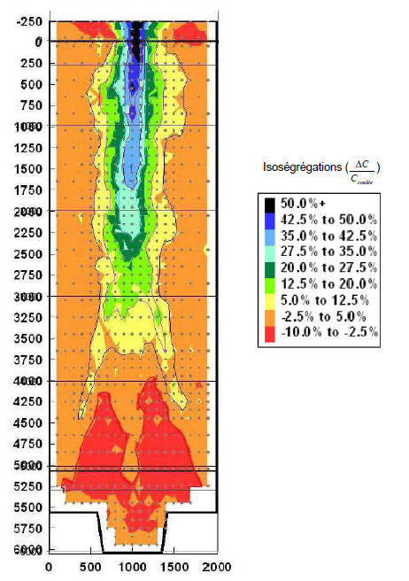
Figure 1 : MOPPEC bloom chemical characterisation

The carbon macrosegregation profile of the bloom does not appear to be completely symmetrical. Two hypotheses can explain this finding:
- Misalignment linked to blooming
- Sampling mesh too coarse and imprecise, or elementary volumes related to the analysis not representative

In order to verify whether the sacrificial bloom showed any outliers, the CRMC (Centre de Recherche des Matériaux du Creusot) was asked to provide characterization data on other blooms and ingots of the LCO2550 type with different feedhead rates, and maximum carbon content values ​​at the casting. Once all the different bloom values were statistically compared, the MOPPEC bloom was regarded as statistically representative (Data for the other blooms has not been included for confidentiality matters).

Simulation comparison to SG 900MWe tubular plates
640 samples were taken from the plate 381 according to a section in the diametric axis of the part (Figure 2).

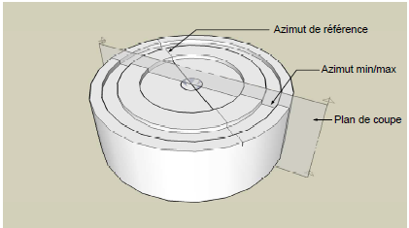
Figure 2 : Sampling plan in the GVRP381 tubular plate

Figure 3 shows the simulation results. When comparing it to the real plate, modelling of segregation appears to be globally satisfying.
The only inaccurate calculations were located in the tubular plate axis, where there is strong positive carbon segregation. The simulation overestimated the actual carbon content by about 12%.
Comparisons were quite accurate for a radius of about 600 mm and more around the plate central axis. For a radius inferior to 200 mm, the simulations overestimated the true segregation rate.

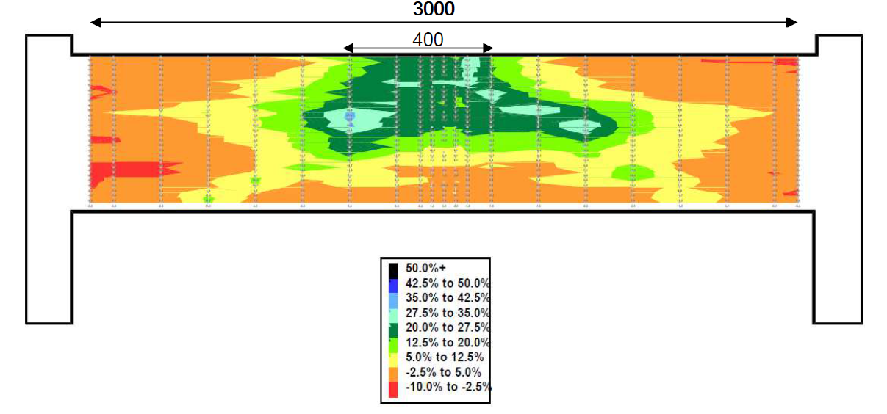
Figure 3 : Graphic visual of simulation results after manufacturing process outline of GVRP tubular plate

Another tubular plate (383) was also dissected and analysed in the same plane of study as the previous one (381), with less samples.
Comparisons with simulation led to better conclusions than those of the first tubular plate: the simulations agree well with the measurements all along the plane of sampling.
In conclusion, the analysis on the tubular plate 383 give good correspondence with the simulations, more than the tubular plate 381 does. This difference is not explainable by the way of collecting samples nor data treatment, which were identical for both plates. Uncertainty from carbon measurements or meshing during sampling are both too weak to induce such large variability. The two hypotheses kept were that meshing step was too large or that these differences originated from the manufacturing process.

Simulation comparison to SG 900MWe channel head
The channel head was not as much analysed as the tubular plates. There was no sampling in the diametral plane. Samples were taken at two stages of forging: at the blank stage (before stamping) on the surface (Figure 4), and at the final stage after the heat quality treatment profile on the surface and through the thicknessa after stamping (Figure 5). The samples are taken on two perpendicular axes (0°-180° and 90°-270°).
In the figure below, the grey and yellow areas correspond to the lesser segregated areas whereas the dark blue and red ones indicate higher and lower segregation respectively. The notation “%C” symbolizes the ratio of the difference to the nominal carbon concentration over the nominal concentration Wc- Wc nominalWc nominal. That ratio quantifies the segregation intensity.

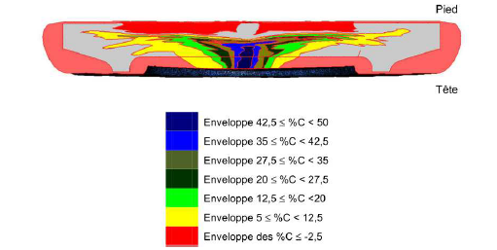
Figure 4 : Carbon cartography from simulation of a channel head at blank state

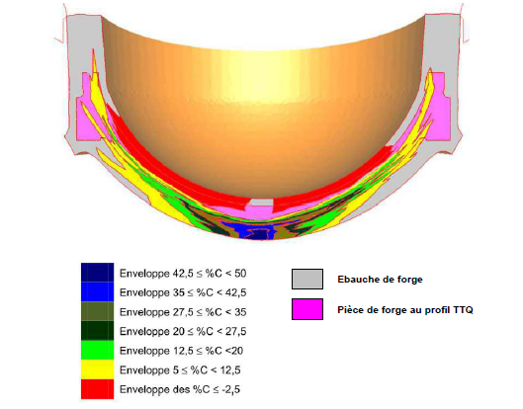
Figure 5 : Carbon cartography from simulation of a channel head after heat quality treatment

The comparisons between simulations and characterizations for the blank stage are satisfactory for the 2 axes investigated, apart from a few points around the centre, indicating a decentring of the part, whose origins are revealed hereunder and in FA3 vessel caps program technical note. The prediction is considered efficient for the blank stage of the GVRP381 channel head.
For the after-heat quality treatment stage, two samples were taken: one at the top of the channel head and one at the bottom. The results of the comparison between the model and the predictions are considered satisfactory, despite an outlying carbon macrosegregation value of -20% at 1750 mm from the centre of the bottom.
For the head sampling, the simulation results become less efficient, especially in areas of maximum carbon macrosegregation. Where the simulation indicates maximum values ​​capped at 30%, analysis highlight experimental values ​​that can reach +40%, corresponding to a 0.02% difference in carbon content of for this grade of the channel head from GVRP381 between experimental and simulation results.
The maxima are also not located at the centre of the bottom, but shifted up to 500 mm, reminiscent of the spatial misalignments mentioned previously and exceeding the shift values ​​observed. This is most likely due to the crushing step in parallel passes of the bloom. This consists in a step-by-step deformation over the entire surface of the blank to flatten it (Figure 7. This operation does not preserve the axial symmetry of the ingot, and the centre of macrosegregation is displaced from the piece of equipment centre in proportion to the size of the tool. This phenomenon of shifting was already observed during the analysis of the Flamanville EPR domes in 2016 (3). This interpretation is plausible according to current knowledge. It is also necessary to consider the existence of a very slight decentring during blooming as discussed later in this report, which may also bear some responsibility for the decentration after forging observed on the head.

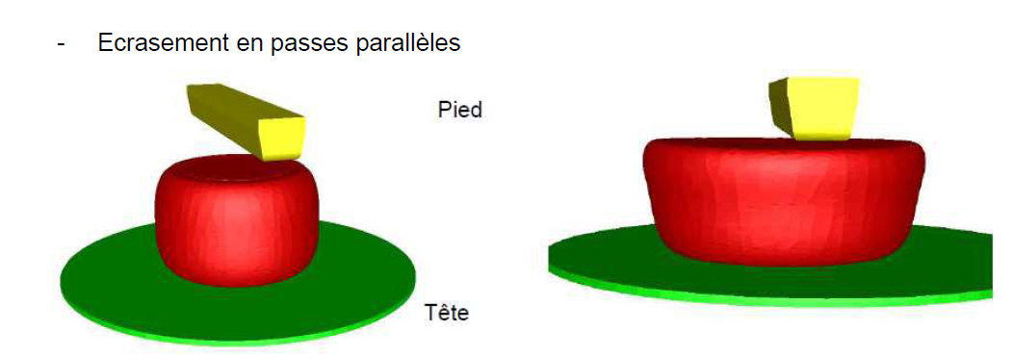
Figure 6 : Schematic of flattening of the blank by parallel passes

Simulation comparison to SG 900MWe elliptic dome
Three samples are extracted from the elliptical dome of a steam generator from Taishan 2 EPR, the first in the centre of the dome, the second at 485 mm from the centre and the third on the periphery of the dome, close to the external contour (Figure 7).

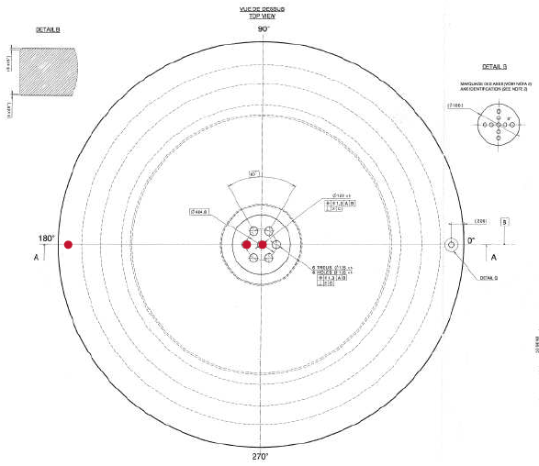
Figure 7 : Schematic of sampling on the dome

The comparison of results between simulation and the two other axial and non-axial cores confirms that the modelling of carbon distribution at any point of the volume is accurate.

Chemical analysis of the bloom in 2016 (4)
The bloom underwent other chemical analysis in 2016 to broaden Framatome’s knowledge about carbon distribution within the semi product and to refine results in specific zones. The goal was also to check if the macrosegregation centre had been intercepted in the previous analysis.
Figure 8 shows the 2012 carbon cartography as well as the planes that were investigated, perpendicular planes shown by the black arrows and one transverse plane in red. In 2016, the analyses were conducted on the same planes.

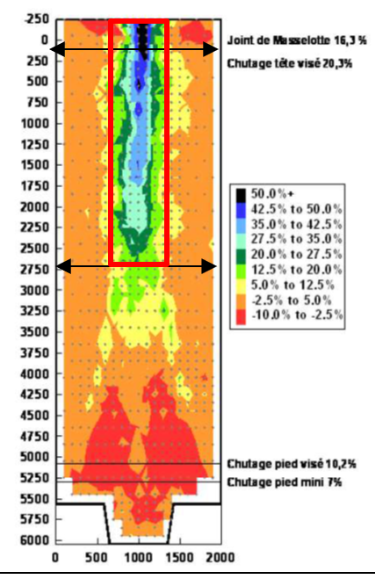
Figure 8 : Carbon cartography of the bloom from 2012 and analysis planes

Three cuts were carried out : two perpendicular to the central axis at 100 mm (Figure 9) and 2750 mm (Figure 10) under the feedhead, and another one along the central axis from the top of the bloom until 2650 mm under the feedhead, intercepting the centre point (Figure 11).

Figure 9 : Perpendicular cutting of the bloom at 100mm under the feedhead

Figure 10 : Perpendicular cutting of the bloom at 2750mm under the feedhead

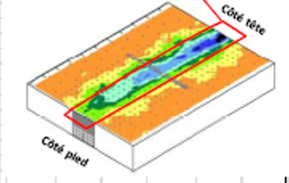
Figure 11 : Longitudinal cutting of the bloom from the top to 2650 mm under the feedhead

For the perpendicular cuttings, these 2016 carbon concentrations appeared slightly lower than those of 2012 but showed that the bloom was well positioned in the centre and that the measured values ​​were indeed the maximum ones.
For the longitudinal cutting, the 2016 analysis leads to a very similar map to that of 2012 with acceptable calculated deviations. The 2016 values ​​are slightly higher than those of 2012.
To sum up, the analyses of 2012 and 2016 are very similar and those of 2012 therefore appear reliable and consistent. The main conclusions are:
- Mapping of carbon content established in the bloom can be used for numerical simulations of the manufacturing process outline.
A very slight offset of the maximum macrosegregation of about ten centimetres is observed with respect to the geometric axis of the bloom. It is probably due to the manufacturing process itself (parallel passes flattening).

Chemical analysis of the bloom in 2019 (5)
The goal of the 2019 campaign was to extend chemical knowledge about the bloom as well as to check again the repeatability of the measurements. Only transverse cuttings were carried out. Three new planes of investigation were added between the two previously analysed planes at 100 mm and 2750 mm under the feedhead.
The 2019 cutting planes are located (Figure 12):
- At 6100 mm level (100 mm below the feedhead)
- At 5250 mm level
- At 4700 mm level
- At 4100 mm level
- At 3500 mm level (2750 mm below the feedhead)

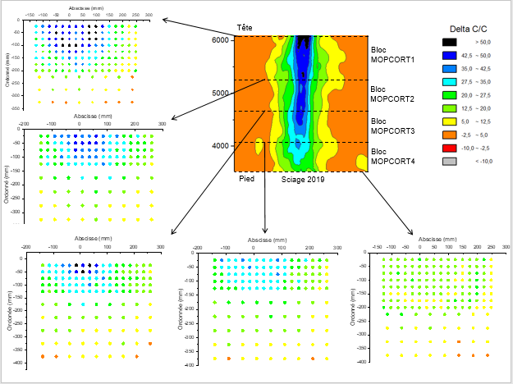
Figure 12 : Visual schematic of cuttings in the bloom

With its 5 cross-sections, the 2019 study made it possible to carry out new measurements for sections already investigated in 2012 and 2016, as well as to extend the carbon mapping database of the bloom. The results showed that the mapping of the three series of measurements agrees with prior work.

Conclusion of MOPPEC project and synthesis work
One of the MOPPEC project objectives is to try to predict the future of carbon macrosegregation after different steps of forging for large 900MWe steam generator parts, such as the tubular plate, the channel head, and the elliptical dome at the blank state. The MOPPEC bloom, from an LCO2550 ingot that has undergone blooming, was analysed during three successive programs carried out in 2012, 2016 and 2019. The carbon segregation map of the bloom is thought to be reliable for the simulation of the manufacturing process outline of piece of equipment manufactured from the same type of ingot. The validation of this carbon segregation prediction program in forgings was carried out by comparison with measurements on industrial parts of GVRP 900MWe and EPR. Results of the chemical analysis show good agreement. However, the overall approach of the modelling program is not yet considered efficient enough from a quantitative point of view to systematically replace dissections of products with numerical simulations. In the current state of knowledge, this lack of performance is not explained. Framatome has been involved in research activities regarding the solidification of large ingots to address these quantitative issues.
This synthesis work occurred at the early stage of my apprenticeship in Framatome. It allowed me to discover a concrete industrial problematic and to contribute to it by centralizing data within a single technical note. This was my first written work which was checked by pairs. I thus obtained a lot of useful feedback to further develop my writing skills and improve efficiency with the Microsoft Word macros, functions, and shortcuts.

Materials database completion (SimDB)
Another project that falls into the technology category was my contribution to Framatome’s database called SimDB. This database was conceived to centralize and capitalize all Framatome’s data regarding manufacturing processes and pieces of equipment. This database would allow easy access to the end of manufacturing reports for every person involved in the analyses of said data.
This materials database aims at becoming the dedicated tool to centralize all experimental data obtained on various parts, whether these data have been obtained in R&D programs or as routine acceptance tests. Framatome currently asks to its whole materials engineering department to collect and verify materials data (chemical and mechanical), to feed this database and enable anyone to study massive amounts of experimental results. In this frame, I was asked to contribute to this task by centralizing manufacturing data relative to channel heads.
The interest of this activity lies not in the preparation of the Excel files needed to feed the database, but in the discovery of detailed manufacturing operations of channel heads, carefully analysed and criticized in a dedicated Framatome internal document. Therefore, I was able to better understand the sequence of manufacturing operations (Figure 13), from the casting of the ingot to the final heat treatment.

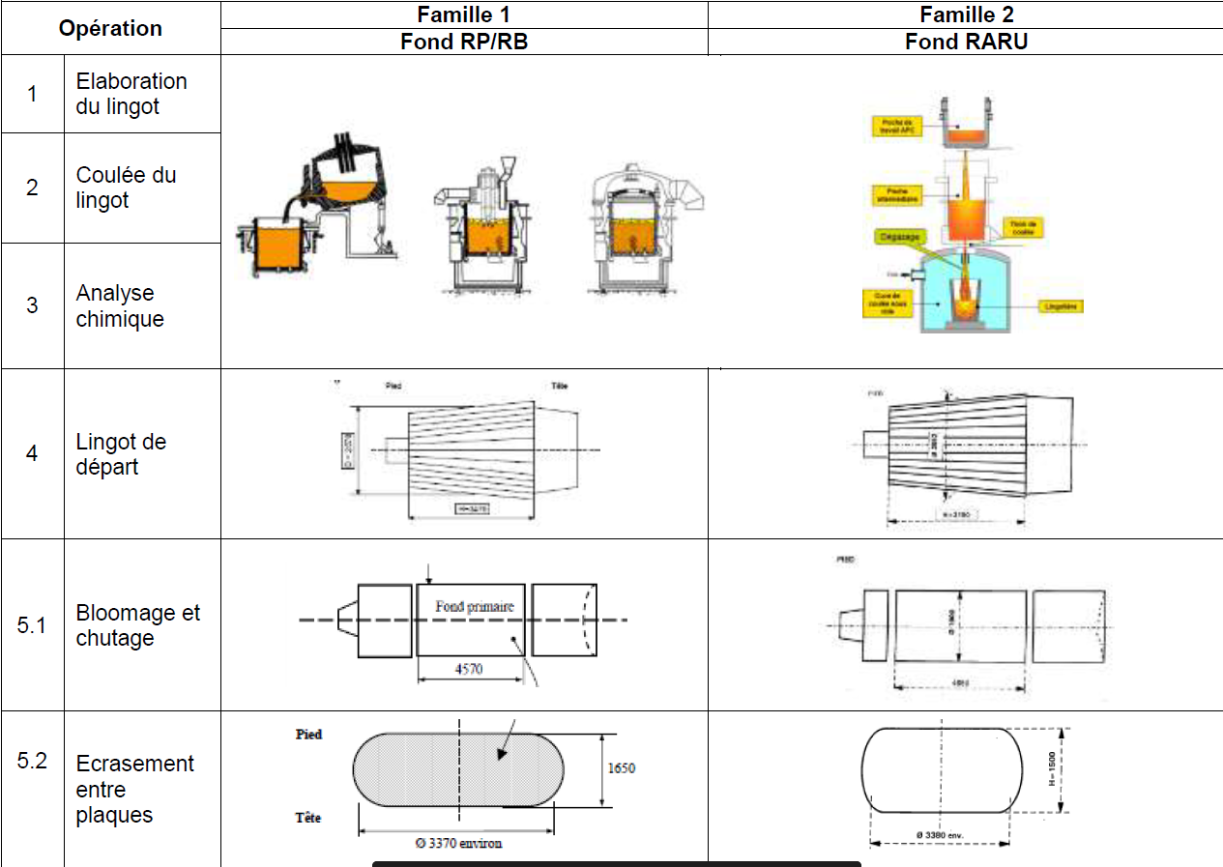
Figure 13 : Part of the manufacturing process outline of the channel heads

The same report also mentioned generic parameters and explained the major reasons why channel heads (among other parts) can suffer from segregations. The following parameters were identified as critical:
- Ingot mould:
- Channel heads are made from a cast ingot. Hence, the mould in which casting takes place is an important parameter. The one used for these channel heads was a type 2550. The mould influences the macrosegregation intensity (and mesosegregations appearance zones).

- Cropping:
- The final part weigh much less than the as-cast ingot. The main reason lies in the top and bottom discarding operations to eliminate most of macrosegregation. Supplementary thickness is also added for heat treatments and machining operations. During hot forming, a loss of matter can occur by fire contact but does not constitute the main matter loss mechanism. All of this gives the bloom dimensions, which are going to be of use to determine the ingot needed size.

- Chemical composition: chemical content is one of the parameters that play the strongest role in segregation formation. COMON (6) developed an equation designed to predict carbon segregation in function of the ingot height/diameter ratio and Si, P, Mo and V content (Figure 14). This formula translates the high contribution of sulphur and phosphorous to the segregation intensity, as well as Mo and V ability to reduce segregation. The H/D ratio of the ingot also demonstrates a strong influence on segregation formation.

Figure 14 : Comon Formula for the estimation of macrosegregation intensity in cast ingots

Later, Creusot LOIRE investigated the effect of some alloying elements such as manganese, nickel and chromium, on channel segregations (7).The equation in Figure 15 highlights the effect of these elements over the specific volume of liquid metal. The greater the specific volume difference, the greater the segregation intensity because of enhanced convection phenomena

Figure 15 : Creusot Loire Formula for three new elements: Mn, Cr and Ni

In conclusion to this SimDB contribution, I was able to help Framatome centralize important data and learn the process of it. I collaterally improved my knowledge of manufacturing process and parameters through the report of Thierry BERGER (8), which was initially used to check the list of channel heads to add to the database. This work showed me the importance of data capitalization to improve databases and internal knowledge.

Research subject: Solidification and segregation mechanisms

As I have been working in the metallurgy section of Framatome, research obviously was a daily interest. Whether it is to collect literature data about a certain topic or to review the latest work on steels, knowing how to search for and read a paper is a key aspect of the engineer work.

Bibliography work

Right after the MOPPEC report, I was given the task of writing a bibliography report microsegregations formation during the solidification of peritectic steels. Technical terms are to be further explained in this part.
The goal of such work was to centralize data from literature about microsegregations, their mechanisms, the studies that had been done in terms of modelling as well as experimental work. The aim of this report was also to get me into how a bibliography work was carried out and get a sample of what a thesis work would be like, should I be interested.

Context
The manufacture of steel parts involves many processes. The main constituent of steels, iron, can come from ore extracted from mines but can also be recycled from unused scrap. This steel is melted, set to grade, and poured into an ingot mould from which it will take the shape. This operation is called casting.
The solidification of the liquid is accompanied by the formation of volume defects, due to shrinkage, porosities, gas cavities and inclusions. Putting a feedhead over the ingot greatly reduces the presence of shrinkage by keeping a pocket of additional liquid metal over the mould and filling any void created by the shrinkage. These compactness defects will be closed during forging operations.

Another important phenomenon during the solidification of liquid steel is the appearance of segregation. This phenomenon is related to three main factors:
- Chemical diffusion
- Partitioning
- Liquid density variation

Chemical segregation can be described at three scales: the macroscopic scale, of the order of magnitude of the ingot (metre), the mesoscopic scale, at grain size (centi- to millimetre), and finally the microscopic scale, at dendrite scale (micrometre). This bibliographic work focused on microsegregation.
The main topics of this work are reported hereunder.

Main topics
Peritectic reaction and transformations
We shall define words from the title : “microsegregations formation during the solidification of peritectic steels”
The etymology of the word peritectic tells us about a phase that melts “easily” (eútēktos) around another phase (“peri”), which shows the nature of the peritectic reaction: two phases that melt together at the same temperature. A peritectic steel is a steel which shows a peritectic reaction during cooling. Steels will exhibit peritectic reaction whenever their carbon content is lower than 0.6%.
Azizi defined three peritectic components: the peritectic reaction and two types of peritectic transformations (9).
This reaction is described for steels as $L+ δ→γ$, meaning that a zone made of liquid and ferrite will transform into austenite. Azizi further explains that the peritectic reaction mechanism was the formation of an austenite layer around the ferritic dendrite, in a liquid medium. This mechanism is shown in Figure 16.

The two steps of the peritectic transformations are described as$δ→γ$ ($γ1$) and $L→γ$ ($γ2$). They are different from the peritectic reaction since they take place when the austenite layer has formed around the ferritic dendrite.
Then, the gammaγ layer grows in both directions leading to two sides undergoing a peritectic transformation: towards the center of the dendrite, where ferrite will transform in austenite ($γ1$) and outwards, where liquid will yield austenite ($γ2$). Even though these transformations occur concurrently, they exhibit different rates of transformation and energy barriers, hence why it is important to distinguish them.

Figure 16 : Peritectic reaction and peritectic transformations mechanisms

Studying microsegregations formation in peritectic steels was of interest because most of low-alloy steels used in Framatome activities solidify following a peritectic scheme. They are also most likely representative of how mesosegregations appear. Mesosegregations being detrimental to mechanical properties, it is therefore of utmost importance to understand how microsegregations take place during solidification. Three different mechanisms in a peritectic steel are responsible for segregation formation.

Diφ=D0e-EaRT

Partitioning
The main reason why microsegregations form is the partition coefficient of elements between two phases. This is a temperature dependent phenomenon. It is a function of the concentration wiϕX of an element i in each considered phase ϕA and ϕB :
kiϕ/θ T= aiϕaiθ kiϕA/ϕB T=wiϕA wjϕB
This parameter represents the percentage of atoms at the phase boundary that will go the ϕA phase and the ϕBθ phase. If kiϕϕA/ϕB/θ T is greater than one, most of the atoms will be transferred to ϕA, should it be lower than one, the ϕBθ phase would pick up most of the atoms. The closer it is to 1, the fairer the partitioning.
There exist multiple phase boundaries within peritectic steels: austenite/ferrite, liquid/ferrite, liquid/austenite… They all have different partitioning coefficients which also vary with temperature as shown in Figure 17 (10).
For example, we can see in graph (a) that upon heating, the carbon partitioning coefficient will decrease from austenite to ferrite. This means that carbon will be more soluble in austenite than in ferrite during solidification. It is actually the opposite for phosphorous and sulfur, which tend to be more soluble in ferrite.

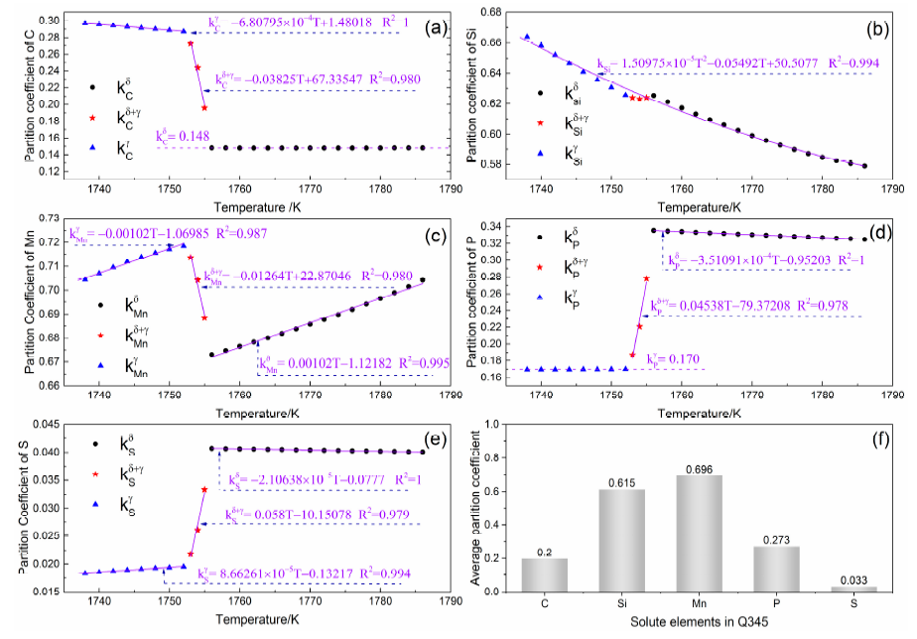
Figure 17 : Examples of partition coefficients for different elements evolution with temperature (10)

Partitioning is not necessarily a negative phenomenon: it can sometimes have very little effect on segregation. The negative aspect about it is when partitioning yields concentration gradients which cannot be further homogenized because of low diffusion rates, which is the case in steels even at high temperatures and very long holding times. The segregation profiles then stay frozen and cannot be eliminated in the final part.
Partitioning in peritectic steels always involves at least one solid at the interface, since only one type of liquid phase can form. Solutes are generally more soluble in the liquid state because of the weak interactions but also of the disorganized nature of the liquid. Solid state means there is a crystalline structure and increased solvability in a solid phase if the pure element exhibits a similar crystalline structure. For example, nickel which crystallizes in a FCC manner, will encourage FCC austenite formation. Other elements like Cr will tend to help the formation of the BCC phase because they crystallize in a BCC structure.

Diffusion
Atom diffusion refers to the motion that atoms exhibit throughout out the volume to minimize chemical potentials. In most simple binary steels, atoms will move to homogenize composition gradients.
In other cases, atom diffusion can be opposite to the homogenization of composition gradients like this would be the case in the Darken experiment, further explained in the DICTRA part of this report.

Diffusion is therefore needed in order to reduce chemical segregations through the homogenization of chemical gradients. It is a problem though whenever it cannot take place and chemical gradients are frozen, symptomatic of insufficient diffusion rates.
These low diffusion rates are mainly caused by 2 situations: solid state diffusion or low temperature diffusion.

Liquid state diffusion is considered to be about 3 orders of magnitude faster than solid state diffusion. This is because in the solid state, atoms motion has got reduced degrees of freedom of motion, since the lattice interstitial and substitutional sites are the only places to which atoms can travel (depending on the nature of the considered elements). Elements such as carbon or nitrogen will occupy interstitial sites, manganese or chromium will occupy the substitutional ones. The energy barrier to move them in order to make diffusion possible is higher than in liquid because atoms are bonded by a strong metallic or ionic bond in a crystal lattice. This results in really weak values of diffusion rates. In the liquid state, however, atoms are not organized in a lattice and can therefore move in many more directions. Moreover, atoms in the liquid are held together by weak Van Der Walls bonds, the temperature is usually higher and there are no preferential sites, meaning the energy barrier to overcome to move an atom will be drastically lowered.

Finally, diffusion is a temperature activated phenomenon. Diffusion increases with temperature according to the Arrhenius law as follows: Diφ=D0e-EaRT. Solid state corresponds to lower temperature than that of the liquid state in steels. Thus, low temperature is an aggravating factor when it comes to diffusion in the solid state. Diffusion, when not fast enough, can then result in the formation of persistent segregations, whether it be at the micro or macroscale.

Considering these elements, it appears that even though microsegregations are, by nature, a driving force for diffusion, temperature is not high enough during forging operations and heat treatments to allow for homogenization to take place. The characteristic lengths of compositions gradients (several hundreds of micrometers) are also too important to overcome. Therefore, segregations cannot be erased during the manufacturing sequence of the parts. It is thus of prime importance to understand what causes these segregations during solidification, since the levels of action are very limited once they are in place.

Convection
At the beginning of solidification, grain nucleation occurs at the centre of the liquid bath. These are denser than the liquid (due to partitioning) and then sink to the bottom, leading to an accumulation of negatively segregated grains. This gives birth to the sedimentation cone as shown in Figure 18. In the meantime, the liquid gradually becomes richer in solutes (liquidus temperature therefore decreases), creating composition gradients. It also progressively cools down. These composition and thermal gradients induce currents, and therefore matter transport, due to a phenomenon called thermosolutal convection. Over time, this leads to the formation of A- and V-segregates in the ingot, and to the appearance of the top segregation under the feedhead.

(11)
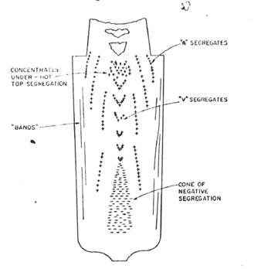
Figure 18 : Locations of macrosegregations within an ingot (11)

As a conclusion, diffusion, partitioning and thermosolutal convection are the three main phenomena responsible for the formation of segregations within an ingot.

Highlighted research
Now that all complex terms have been defined, important conclusions extracted from literature and gathered in the bibliography with a short explanation are to be listed down below:
- Addad stated in his thesis (12) that columnar grains suffered from less segregations than equiaxed grains. The two grain textures have been compared with optical micrographs (Figure 19). The explanation is the carbide formation and the natural segregation at the end of the solidification, when equiaxed grains form coincidently because of low heat extraction rates.
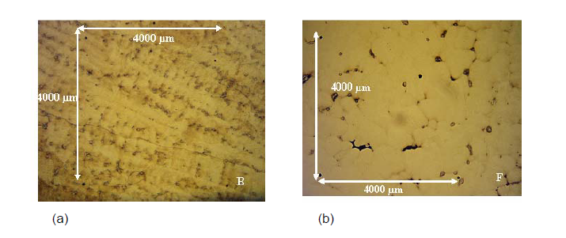
Figure 19 : Micrography of columnar zone segregation (a) and equiaxed zone segregation (b)

- Sarkar et al. (13) concluded that different cooling rates did not impact the composition of dendrite cores, whereas a slower cooling rate showed less intense segregations in the interdendritic zone. The given explanation was that homogenization through diffusion has a longer action time window at lower cooling rates.

- Alan Turkeli and David H. Kirkwood showed that ferrite as the first deposited solid decreased manganese segregations (14). They measured two ingots composition after solidification, one having more carbon than the other, and compared the two extrema values (Figure 20). The explanation given is that manganese will diffuse faster in a ferrite phase due to it being less compact than austenite.

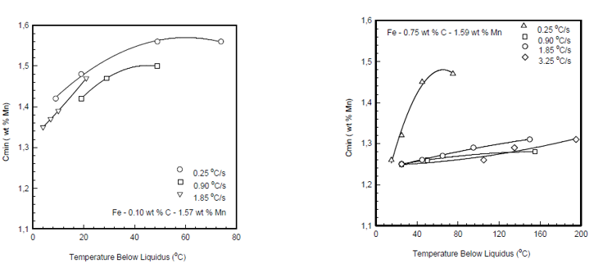
Figure 20 : Comparison of manganese concentration after solidifcation of two ingots with varying carbon content and cooling rates

- YOUNG-MOK WON and BRIAN G. THOMAS suggested a simulation model which to date fits best solidification so far. Their model is almost as accurate as results from FEM, without needing as much time (Figure 21) (15).

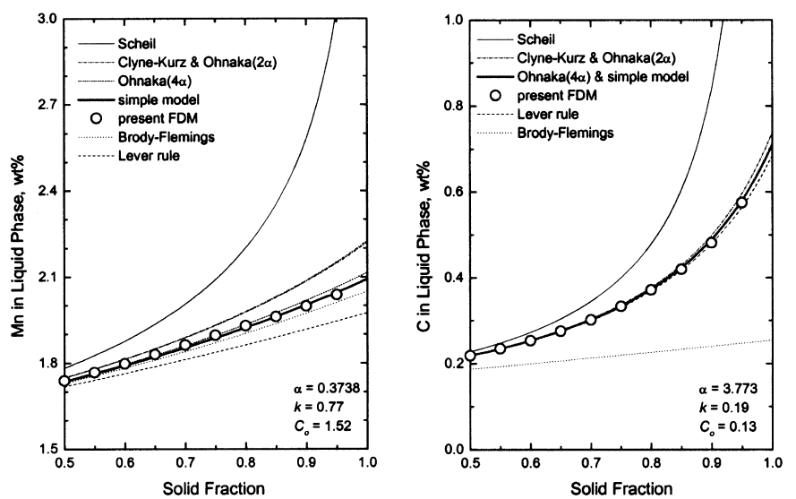
Figure 21 : Comparisons of different models accuracy for segregations of manganese and carbon

Their model is derived from Brody and Flemings (16) original equation:
$$C_{L,i}= C_{0,i}{(1+ f_{s}\left(β_{i}k_{i}-1\right))}^{(1-k_{i})/(β_{i}k_{i}-1)}$$
where${ β}_{i}= 2α_{i}^{+}\left(1-exp\left(-\frac{1}{α_{i}^{+}}\right)\right)-exp(-\frac{1}{2α_{i}^{+}})$ ;$α_{i}^{+}= 2\left(α_{i}+0.1\right)$and $α_{i}=\frac{D_{s,i}t_{f}}{X^{2}}$

- Huang et al. have concluded that even though diffusion and partition coefficients varied significantly during cooling and phase transformations, only variations of the partitioning coefficient truly impacted the intensity of segregations (17). Their simulation allowed to freeze the value of either one of both and study their individual effect on segregation.

Conclusion
To conclude on this bibliography work about microsegregation, it allowed me to understand better how the research part of the R&D was carried out within my company. Going through the process of finding relevant studies online and synthetizing the part that truly matters without leaving major details aside is a great way to enhance skills in that aspect. The role of a bibliography work is to centralize data within a single document accessible by anyone who belongs to the company to spread knowledge throughout the current generation of employees and those to come. Being able to create such a document represents a skill that will be of value to my next employers.

Simulation subjects
As my subject in Framatome mainly gravitated around solidification and phase transformations, I was trained on the software Thermo-Calc in order to run calculations for the company.
Thermo-Calc is a software used for calculating thermodynamic equilibriums and modeling the properties of materials, developed by the Swedish company Thermo-Calc Software AB. This numerical tool makes it possible to follow the evolution of parameters of a multinary system such as the molar/mass concentration of elements from its non-equilibrium state to its equilibrium state. There are several materials databases usable for calculations, such as the ceramics or metals database, the latter of course being the one of interest for metallurgy.

Its particularity is such that the calculations and modeling carried out only take into account the thermodynamic aspects governing the cooling of a system, thus omitting a good part of the detailed description of these processes. The most important assumption to remember for these calculations is that infinite time is given to the system to evolve.. In other words, at any instant, the concentration of elements in any phase will be homogeneous and equal to what the phase diagrams at thermodynamic equilibrium predict.
In research and development, this software saves time and money because it avoids having to go through experimental characterization, which often turns out to be costly.

Thermo-Calc : Simple calculations
I was given different kinds of calculations to carry out to get familiar with the software. The first one was to draw the binary phase diagram of Fe-C. The calculations start off by element selection as well as phases that will form. Iron and carbon were selected as well as cementite, ferrite, and austenite to draw the traditional phase diagram. After setting the Y-axis to temperature and the X-axis to fraction of Fe, the following diagram shows all the existing domains found in the traditional binary diagram. (Figure 22).

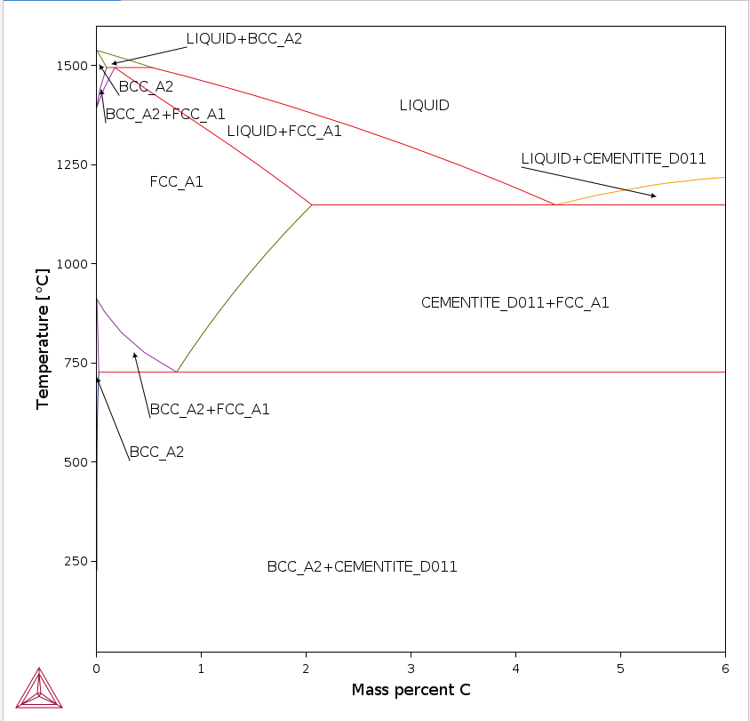
Figure 22 : Fe-C binary phase diagram from Thermo-Calc

We can tell that for binary phase diagrams, Thermo-Calc is a helpful and accurate tool. However, it does not only draw diagrams, but also allow to draw the evolution of chemical potentials over temperature in certain phases, evolution of phase fraction during cooling, etc.

In Figure 23, is shown the evolution of phase fraction for a hyperperitectic steel (Fe-0,2%C) during heating up to liquid state. Simulation starts at about 500°C and we can see that the steel is mainly ferritic with about 97% of ferrite and 3% cementite. We can observe at about 725°C an isothermal transformation taking the shape of a plateau. This corresponds to the eutectoid transformation plateau where austenite appears while consuming both cementite and ferrite. After that plateau, austenite will continue to grow consuming only ferrite up until 835°C. From there up to 1495°C, austenite is the most stable phase. Austenite starts to transform back to δ-ferrite and liquid at 1497°C. This is the peritectic reaction earlier described in Azizi’s work (9) where liquid and austenite will yield ferrite and liquid. From there up until 1520°C, the ferrite-liquid partial melt will continue melting until reaching 100% liquid state.

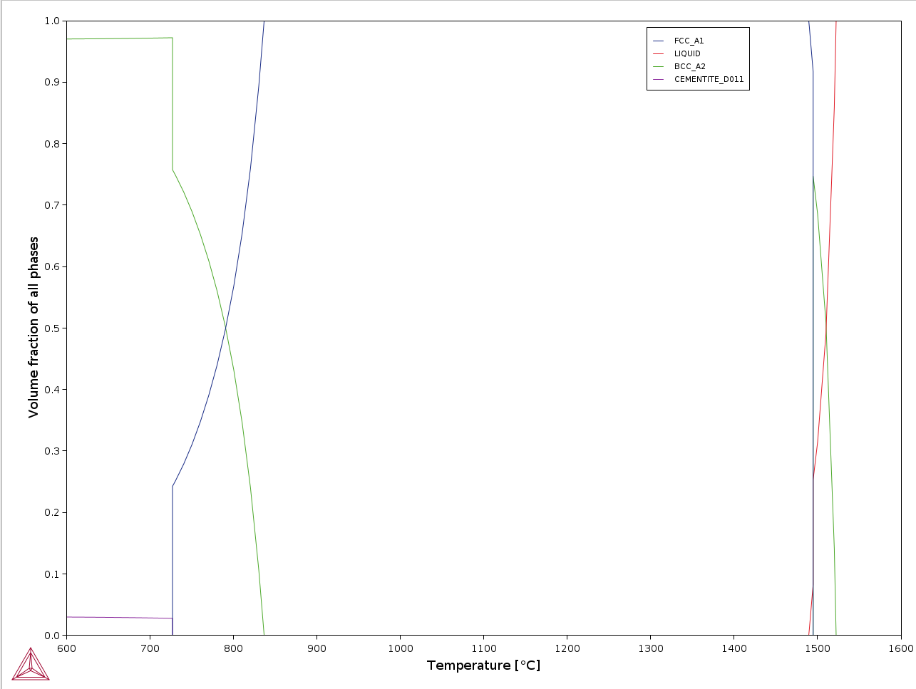
Figure 23 : Evolution of phase fraction during cooling of a hyperperitectic steel (Fe-0,2%C)

This calculation illustrates the capacity of the software to model heating of a binary alloy according to the phase diagram and to give output of a clear and accessible diagram.
Many other features are available on Thermo-Calc, but it is not the goal to show them exhaustively in this report but to rather give a sample.

Thermo-Calc : DICTRA

Quick guide-through (18)
In reality, time-dependent diffusion takes place during phase transformations. This is due to the existence of chemical potential gradients originating from the redistribution and accumulation (or depletion) of solute at the interface of the phases. So, the purely thermodynamical approach of Thermo-Calc is sometimes not enough to understand phase transformations.
The purpose of the DICTRA extension is to model matter diffusion. It thus makes it possible to analyze the way in which diffusion-controlled phase transformations take place.
I was given the task to elaborate a technical note that aimed to guide new users of the DICTRA extension through the set-up of calculations as well as the post-processing of results of these simulations. This technical note gave a step-by-step approach of the interface provided with snapshots of the software to illustrate it.
Then, classic case studies were reported and commented in this guide, in particular the Darken experiment (uphill diffusion). The goal was to give new users concrete examples of what kind of problem DICTRA is capable to handle.

DICTRA extension is made up of 3 modules “System definer”, ”Diffusion calculator” “and "Plot renderer “.
The “System definer” module has got 6 tabs to set up the calculations: “elements”, “species”, ”phases and phase contribution”, “components”, “data sources” and “description”. In Figure 24, the element tab is shown. In this tab, the elements can be selected as well as their composition. Depending on the chosen database, elements can be excluded from the selection. Here are the elements available for the Metals database. One can also choose here the phases of interest for the upcoming calculations.

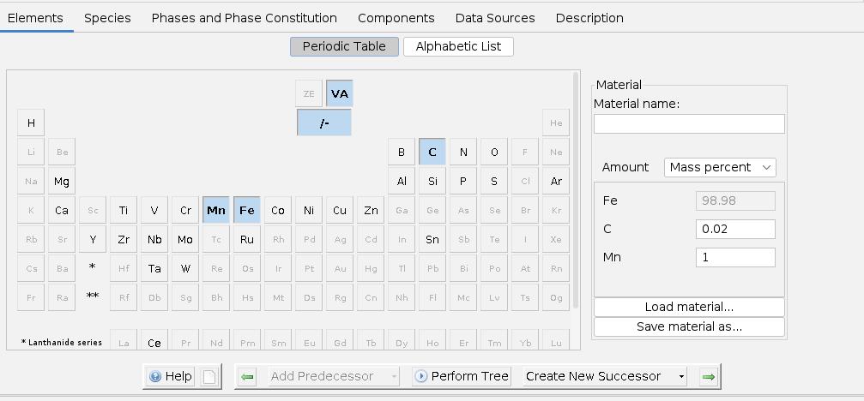
Figure 24 : Elements tab in System definer module of DICTRA extension

The “Diffusion calculator” module consists in 2 tabs, “Conditions” (Figure 25) and “Options”.
The first one allows us to give shape to the calculation, meaning the geometry (planar, spheric or cylindrical), the length unit (m, µm, nm or Å) as well as the number and proportion of phases. The chemical distribution of each element can also be set to a specific profile for non-homogenous profiles.

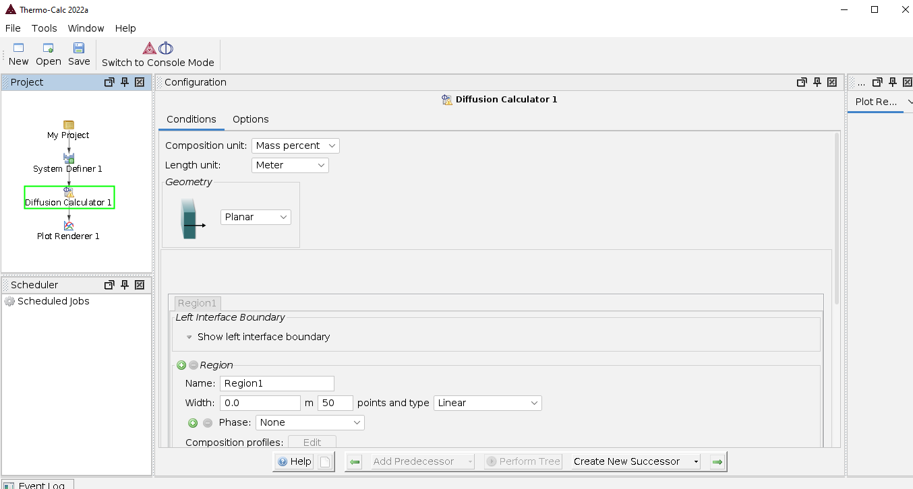
Figure 25 : Conditions tab in Diffusion calculator module of DICTRA extension

In Figure 26, an example of calculation conditions is shown for the modeling of diffusion at the interface of ferrite in a region of about 97 µm and in a cementite region of 3 µm. This corresponds to a likely situation during heating of Framatome steels. where austenite can form in between these two phases. Mesh is geometrically distributed around the interface where it is expected to show the most chemical content variations, hence why more points were needed.

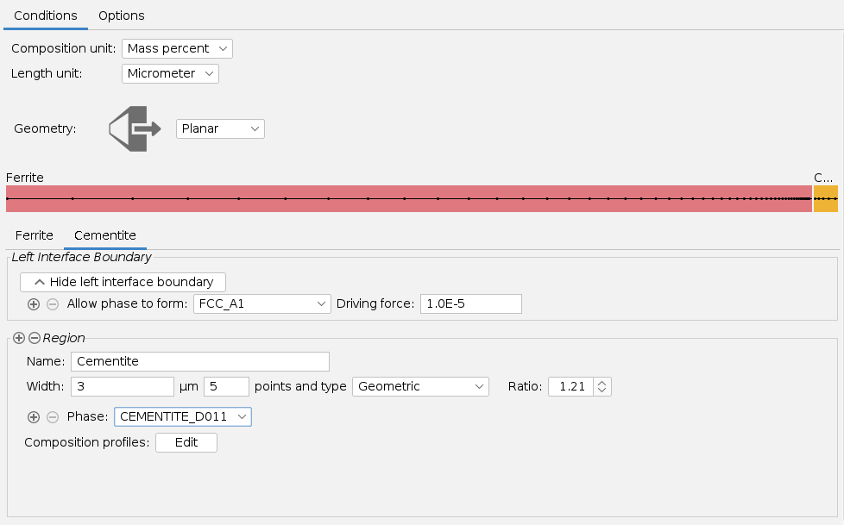

Figure 26 : Conditions of a calculation: modeling of diffusion at the interface

In Figure 27, an example of “step” chemical composition distribution is shown. Step has been added at 97µm at the interface of cementite and ferrite. DICTRA allows to distribute chemical content in this way, linearly or according to a function of the user choice.

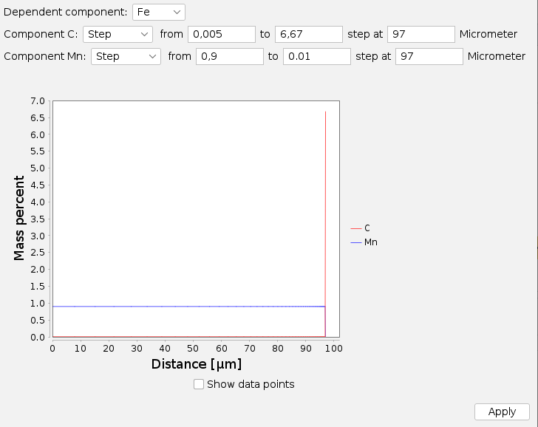

Figure 27 : Example of chemical content distribution: Step

Finally, the results of the simulation are displayed in the plot renderer module as shown in Figure 28. Axes can be given different variables like Time, Distance, Composition, Activity of component, Phase fraction etc.

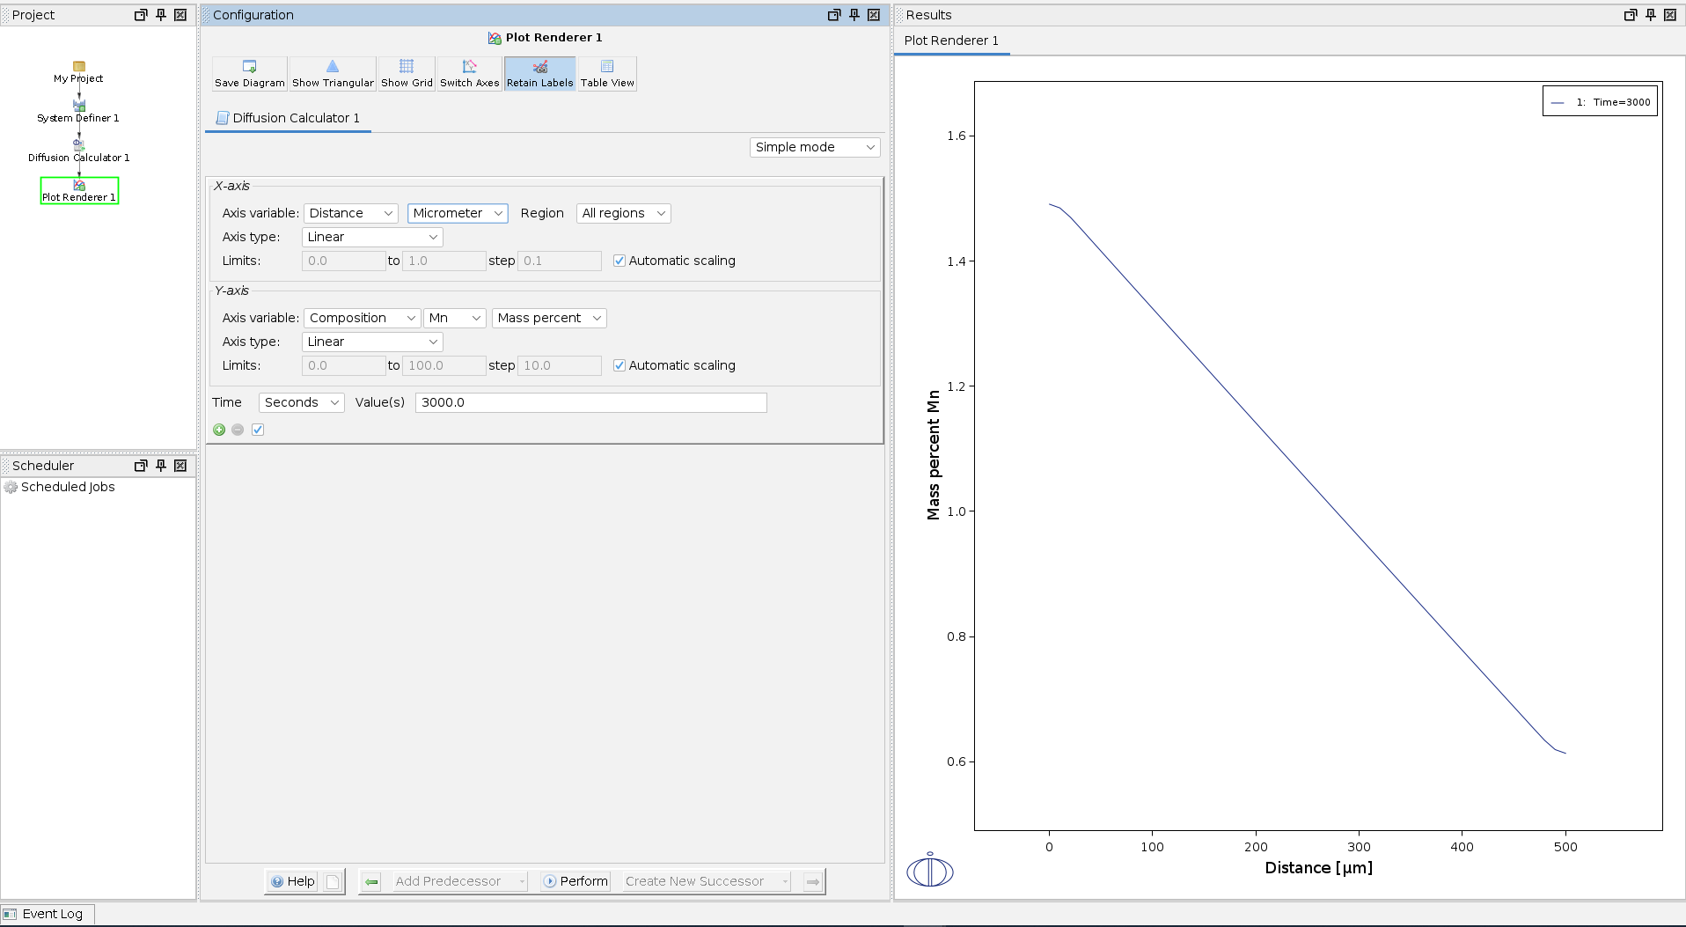
Figure 28 : Plot renderer module tab

Other settings are available such as the axis scaling, variable unit or at which time of the calculation should display the results. Raw data can be extracted in a table in order to process it in other software like Excel.
Each tab was exhaustively described within the user guide and to do so, the process consisted in figuring out the function of each tab button experimentally through parametric analyses.

Illustrating calculations
Elected calculations to illustrate DICTRA use must either be relevant to Framatome or scientifically interesting. With that in mind, the Darken experiment was chosen.
In the middle of the 20th century, it was widely accepted that, in presence of a composition gradient, diffusion of elements took place towards the lowest concentrations. However, and to support previous work having shown that this was not necessarily the case in systems with more than three elements, Darken decided to contribute experimentally to the demonstration of a phenomenon called “Uphill diffusion”, which is the diffusion in the opposite way of composition gradients.
In 1948, he therefore studied the diffusion in a weld between samples of different carbon, silicon and manganese compositions. The assembly is brought to 1050°C for approximately 2 weeks. The observed diffusion was such that low-carbon areas became even more depleted, while high-carbon areas became more enriched.
The chemical characteristics of the samples as well as those of the welds are recalled in Figure 29. Samples a and d as well as weld number 3 will serve as experimental conditions in DICTRA to illustrate the phenomenon of Uphill diffusion. Sample a is a steel at 0.49%C, 0.25%Mn and 3.80%Si, and rod d, a steel at 0.58%C, 6.45%Mn and 0.14%Si. Other elements are disregarded because they are only traces.

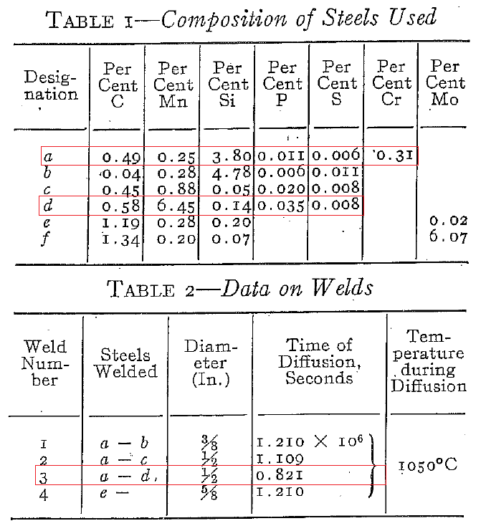
Figure 29 : Summary of the characteristics of the two alloys of the study as well as weld 3 (19)

In the System definer module, the relevant elements (Fe, C, Mn and Si) are selected. The welding is an isothermal treatment in austenite, so it was the only phase selected for the calculation.
In Figure 30 is shown the condition tab for Darken experiment. An austenitic domain was chosen with center-distributed mesh, where the strongest chemical gradients are expected. 127000 µm correspond to the total width of the two rods of about an inch.

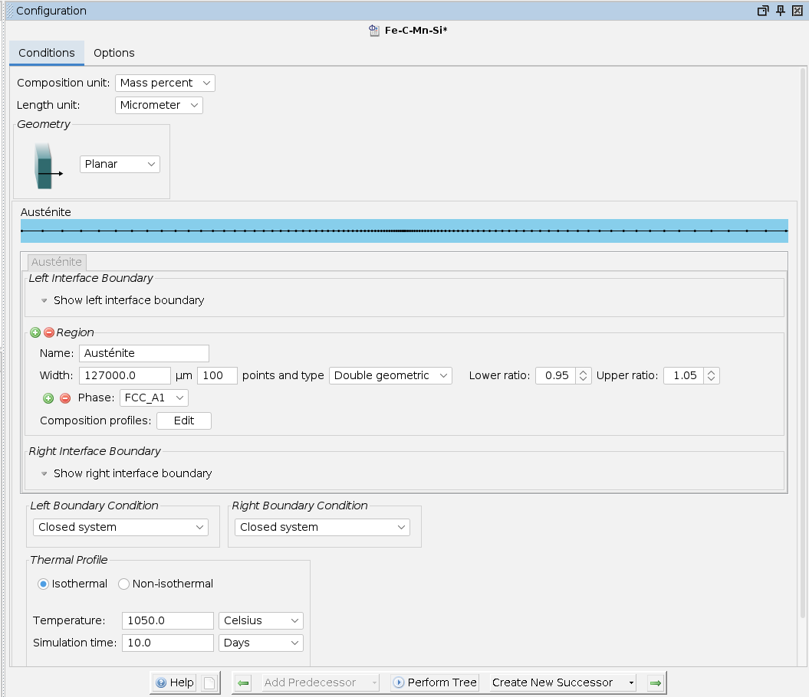
Figure 30 : Conditions tab in diffusion calculator module for the Darken experiment

Then, the chemical compositions were defined as follows in Figure 31. A step distribution was chosen in order to simulate the abrupt change of composition at the frontier of the two rods. The simulation was then set to 10 days at 1050°C and run as is.

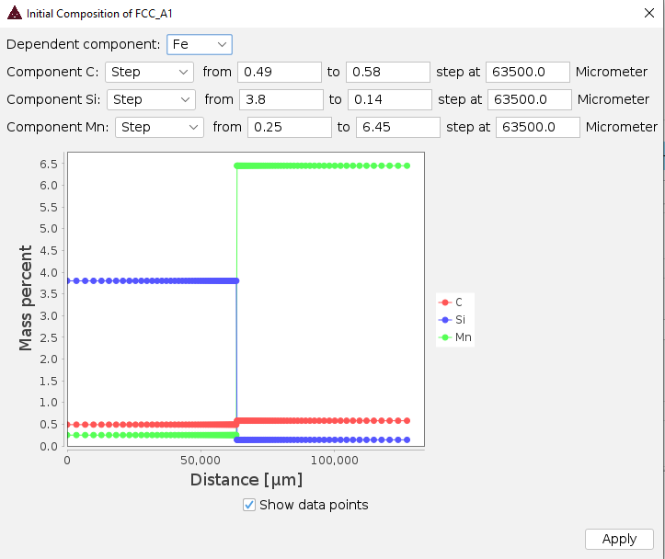
Figure 31 : Chemical content distribution of the two rods

The results of the simulations (Figure 32) are compared with those of the Darken experiment (Figure 33).
The carbon profiles are compared between the Fe-C-Mn-Si system and the binary Fe-C after 10 days of heat treatment. Red curve represents 10 days of heating for the quaternary steel, blue curve is for the binary steel after 10 days of heating, and the green et purple curves, which merge, depict the initial composition profile of carbon. It is observed for Fe-C that the carbon-rich zones are depleted in favor of the less rich zones by homogenizing the composition gradients. The opposite is observed for the Fe-C-Mn-Si system: the rich areas have become even more enriched to the benefit of the carbon-poor areas. This major difference in diffusion between these two systems, binary and quaternary, illustrates the principle of Uphill diffusion.
In a binary system, looking at the composition gradients to predict solute migration is sufficient, while it is not for a multiary system. It is necessary to consider the interactions between solutes and to be interested in the evolution of chemical potentials or activities to understand the diffusive behavior of atoms.

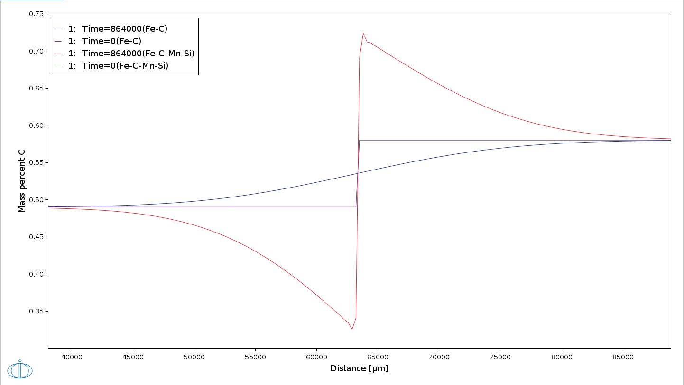

Figure 32 : Results of the Darken experiment simulation

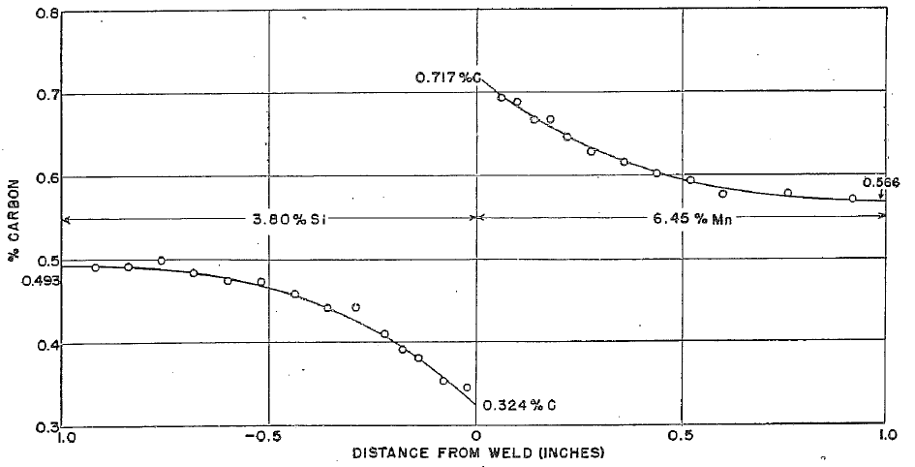
Figure 33 : Darken experiment results as shown in literature (19)

To study the individual effects of silicon and manganese, two other calculations were carried out: one with the Fe-C-Mn system, the other with the Fe-C-Si system. The carbon composition profiles are compared after 10 days of heat treatment for the Fe-C-Mn, Fe-C-Si and Fe-C-Mn-Si systems.
The carbon content is plotted as a function of time for the Fe-C-Si system in green, in red for the Fe-C-Mn system and in blue for the quaternary system (Figure 34).
An influence of manganese on the activity of carbon, which must migrate to a region where its activity is lower, is visible thanks to the red curve. Indeed, the carbon composition profile shows an enrichment of carbon-poor areas towards areas already rich in this element.
The effect of silicon alone on the carbon composition profile, visible on the green curve, is of the same type as that described for manganese, but stronger.
Finally, the combined effect of these two elements on the carbon composition profile is greater than the sum of the individual effects of the elements.
In summary, the presence of silicon in large quantities in austenite increases the activity of carbon, which causes its migration to sites less rich in silicon where carbon potential is lower (independently of the carbon composition therein, for the studied contents). It is the opposite for manganese, whose presence decreases the activity of carbon and stabilizes it in the austenitic region enriched in manganese.

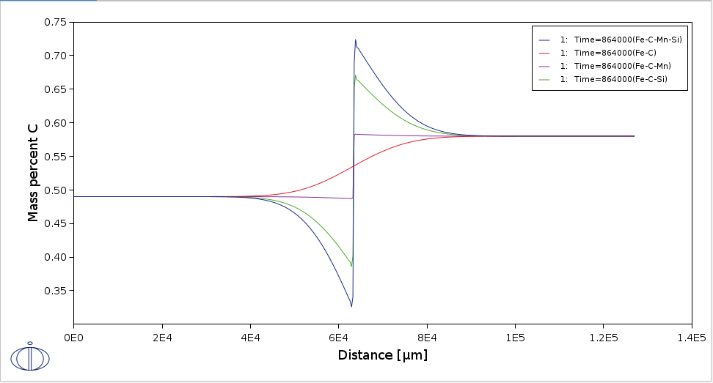
Figure 34 : Comparison of the evolution in composition of different systems (Fe-C, Fe-C-Mn, Fe-C-Si, Fe-C-Mn-Si)

Regarding the chemical activities, the graphs presented in Figure 35 allow us to obtain more information.
The figure below shows the carbon activity for each of the four different steels studied. In purple, the Fe-C steel shows a difference of potential meaning carbon is more stable on the left rod. However, this is not the case when Mn and Si are added in Fe-C-Mn and Fe-C-Si steels, as the potential difference is greater but also, indicates a higher stability this time in the right rod. This means a strong diffusive driving force in the opposite direction to that of the compositions gradients. This is called the phenomenon of countercurrent “uphill” diffusion.
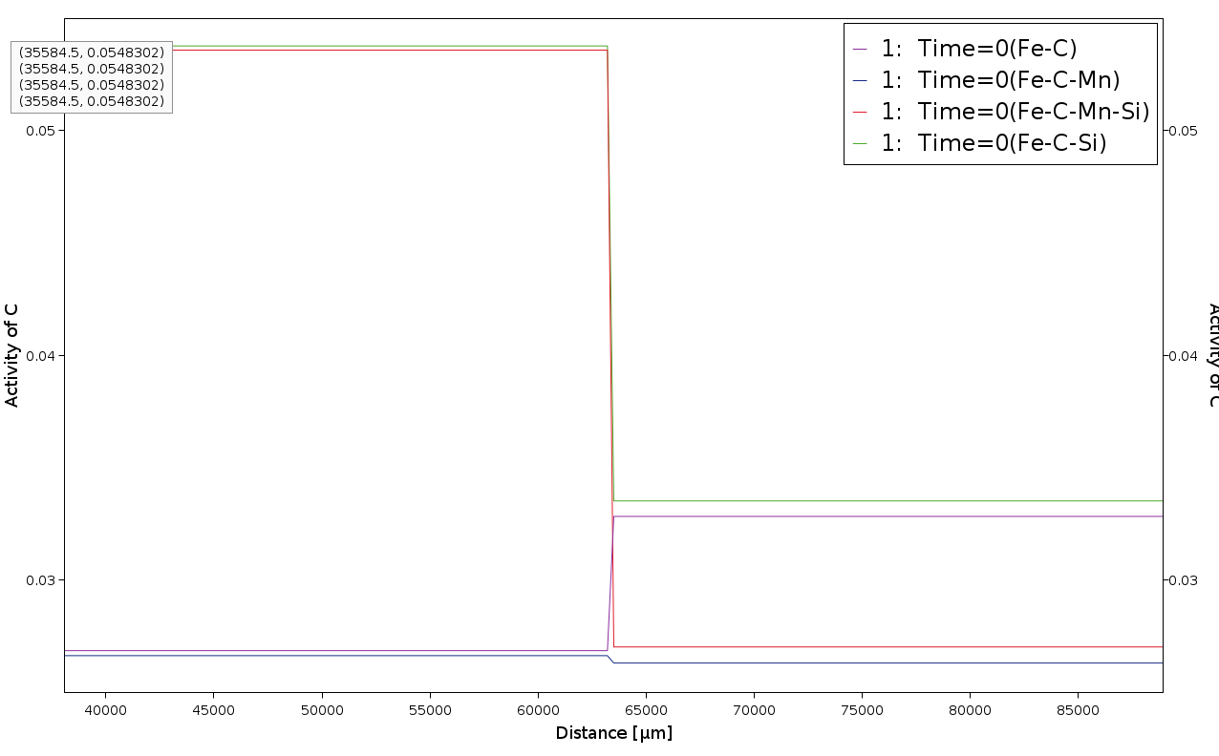

Figure 35 : Initial chemical activity for carbon in each steel

Darken experiment was a breakthrough in metallurgy as it highlighted the complex nature of element mobility within steels and that diffusion was not only due to composition gradients but also interactions between atoms. It was of pedagogical interest for me to get familiar with the experiment and the phenomena involved to understand better atom distribution within steels, and a very relevant choice of illustration for DICTRA extension, due to its remarkable agreement with experimental results.

Thermo-Calc : Steel Properties module

Another Thermo-Calc extension that was bought by Framatome with DICTRA is the Steel Properties module. It allows users to calculate steels important properties based on their chemical content. Properties include crack susceptibility coefficient, interfacial energy, yield strength, liquidus and solidus temperatures as well as drawing diagrams such as the CCT (continuous cooling transformations) or the TTT (Time Temperature Transformation) diagrams.
These diagrams are of interest for Framatome because they can describe the phase transformations that occur during cooling at a certain speed or during heat treatments. Ultimately, the nature of the phases that will form and their proportions will define the steels mechanical properties. For example, a steel containing mainly martensite will be stiff and brittle, whereas a steel only showing ferrite will be more ductile.
Framatome has access to an extensive CCT and TTT diagrams database that mostly dates back to a few decades ago and were determined experimentally.
The goal of using this Thermo-Calc module was to compare these experimental, reliable diagrams to what Thermo-Calc would draw through the Steel Properties module for the same chemical content, grain size and austenitisation temperature. Should the simulated diagrams be accurate for both simple and complex steels, this would open the door to its use for Framatome activities with trust. This would mean a quick, reliable and easy access to CCT and TTT for some steels that Framatome were to use.
The investigation started off with relatively simple quaternary steel grades. The 1-½ Mn, and 1-¾ Mn grades were used for the input data simulations.

1-½ Mn CCT diagram
The available experimental CCT diagram is expressed in terms of cooling rate, because the x-axis is in °C/min. This means that this graph is read vertically, while the CCTs in time are read according to the plotted cooling curves (Figure 44).
Because of Thermo-Calc using log(°C/s) unit axis, a table of conversion for some values can be found in Figure 36 to make graph reading easier.

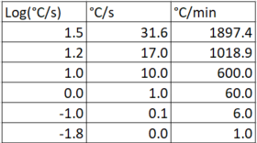
Figure 36 : Table of conversion from log(°C/sec) to °C/min

A range of cooling rates has been studied; it is framed in red in Figure 37. It is expected to see on the simulated diagram of Thermo-Calc a bainitic, ferritic and pearlitic domains.

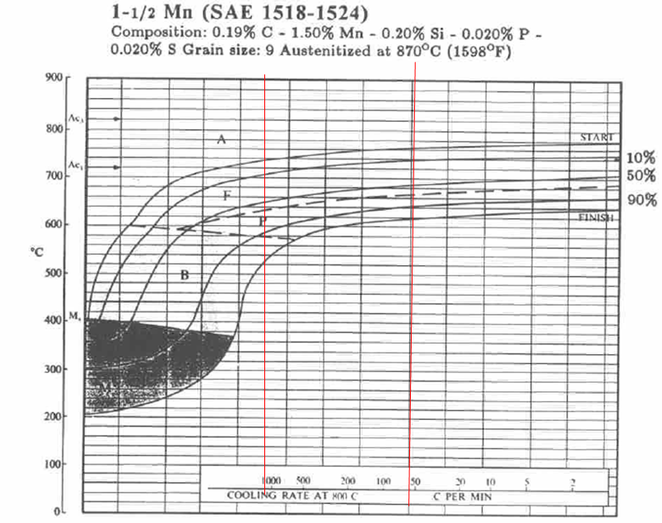
Figure 37 : 1-1/2 Mn CCT diagram from literature and range of analysis

After obtaining the calculations, a simulated CCT was plotted in Thermo-Calc (Figure 38).
It can be seen at first glance that the orders of magnitude of temperature and cooling rate correspond well to the literature. On closer inspection, the graph shows quantitative inaccuracies. The curves at the beginning of perlite and bainite formation should overlap in a cooling rate range between 60°C/min and 1000°C/min. However, in the simulated diagram, the pearlite domain stops when the bainite starts at 0.5, which corresponds to a cooling rate of about 480°C/min, well outside the existence range of bainite. We should have expected them to be continuous and overlapping from 1,2 to 1,25. Also, the 98% transformed austenite curve is too low in temperature compared to the literature diagram.

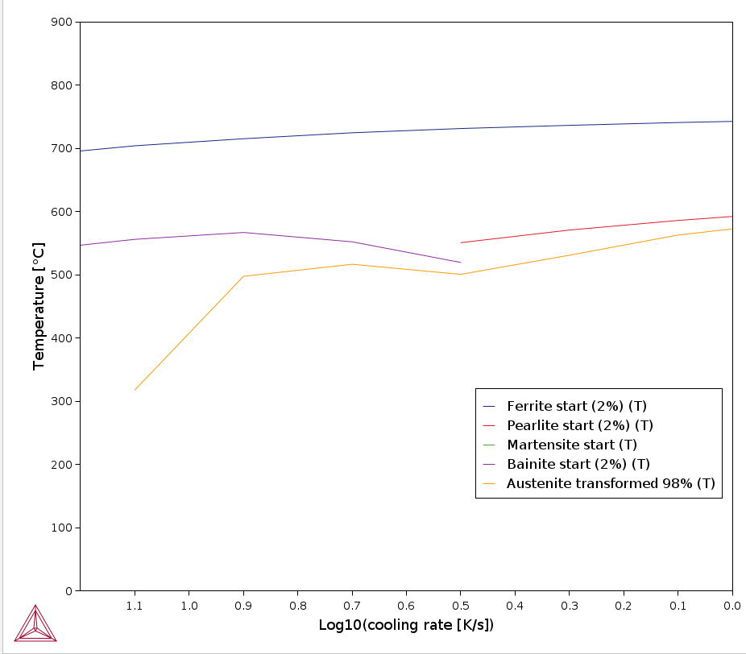
Figure 38 : Simulated 1-1/2 Mn CCT diagram on Thermo-Calc

A superimposition of the simulated and reference CCT allows to better visualize the inaccuracies of calculations (Figure 39).

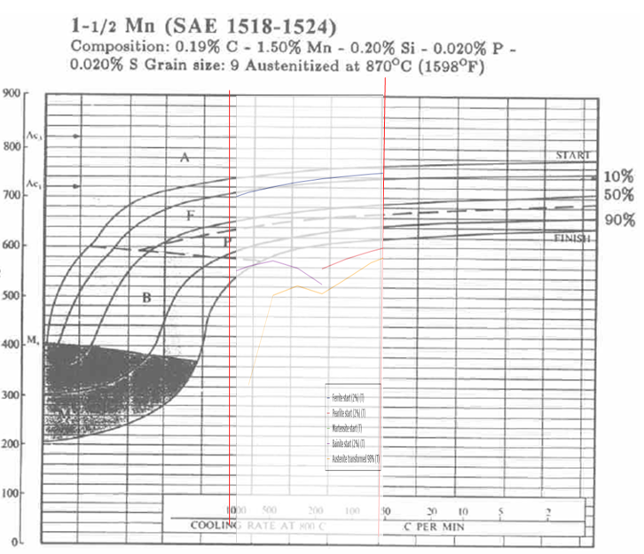
Figure 39 : Superimposition of simulated and reference CCT diagrams of 1-1/2 Mn steel

1-3/4 Mn CCT diagram
The same approach was used for a simple neighboring shade, 1-3/4 Mn, of the following composition: 0.38% C - 1.80% Mn - 0.25% Si. The CCT from literature and speed range analysis are shown in Figure 40.

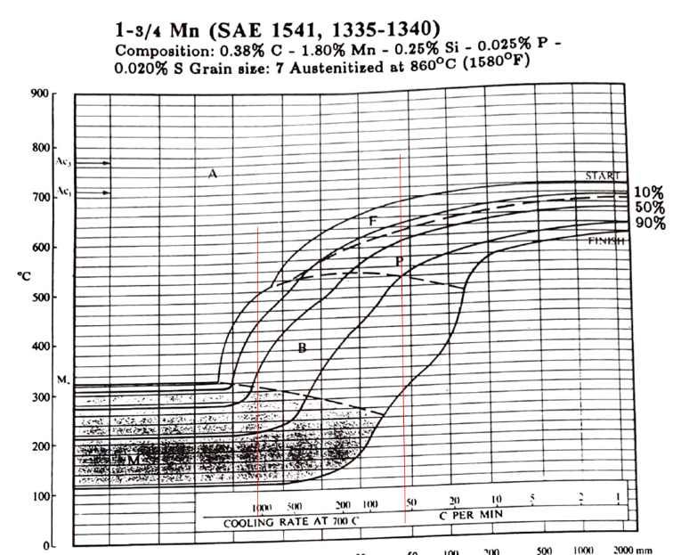
Figure 40 : 1-3/4 Mn CCT diagram from literature and range of analysis

The diagram obtained in Thermo-Calc is inserted below (Figure 41). Here too, there is a discontinuity between the curve of the beginning of perlite and bainite when they should be superimposed on practically the entire analyses speed range.

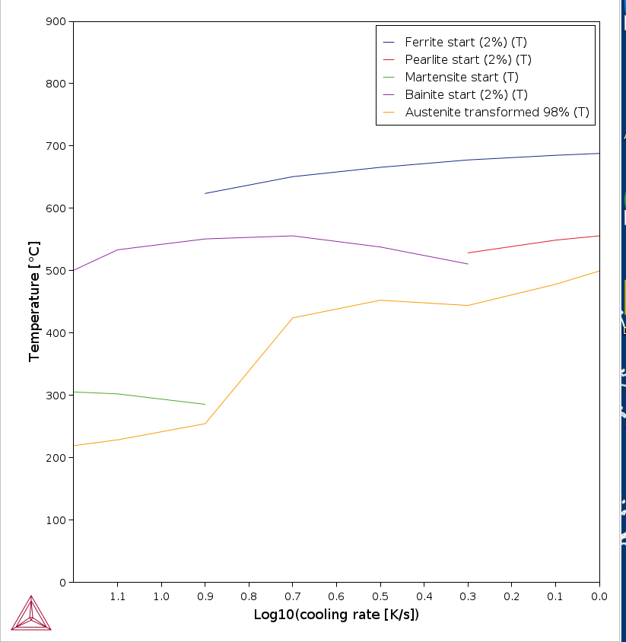
Figure 41 : Simulated 1-3/4 Mn CCT diagram on Thermo-Calc

The superimposition of the reference and simulated CCT (Figure 42) shows better overall accuracy which however is not quantitative. Bainite, pearlite and martensite start are at about the right order of magnitude but have different curve shape. The 98% transformed austenite curve sits at the same height or higher than the 90% transformed curve in the reference CCT, which clearly indicates a lack of simulation performance.

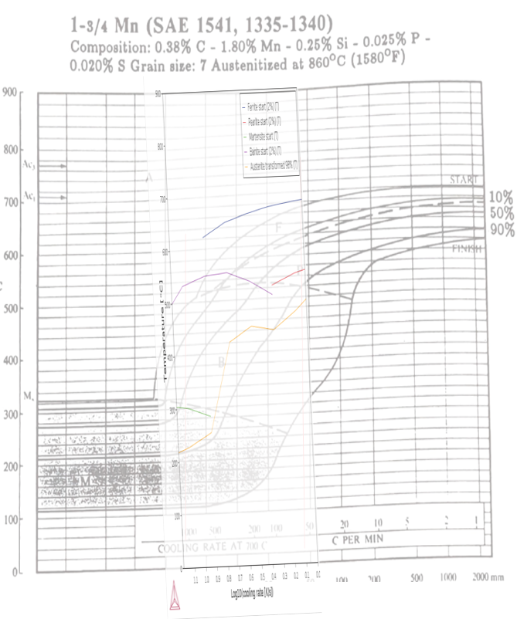
Figure 42 : Superimposition of the reference and simulation CCT diagrams for 1-3/4 Mn

In the Steel properties module, the calculation mode can be set to "Quick", "Accurate”, or "Custom". The difference between "Quick" and "Accurate" has been investigated and reveals few differences, at least not great enough to be considered significant. The superposition of two additional diagrams (Figure 43) highlights these aspects. None of both are considered more accurate regarding literature.

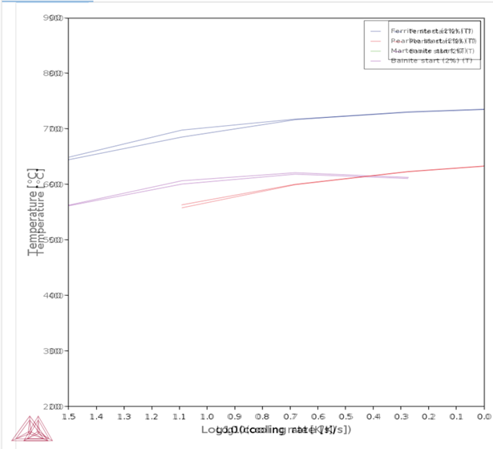
Figure 43 : Superimposition of the "quick" set and "accurate" set simulation for the 1-3/4 Mn CCT diagram

So far, the Steel Property module did not really show any quantitative interest for simple steels, and it was likely to not show any either for more complex ones. However, 2 more complex steel grades used by Framatome were still investigated in order to have a concrete state of the art.

16MNDS CCT diagram
16MND5 steel grade is a 7-element grade widely used, of chemical composition 0.18% C – 1.3% Mn - 0.2% Si – 0.2% Cr – 0.75% Ni – 0.5% Mo. The diagram from literature is inserted below (Figure 44) and is naturally more complex than those of the 1-X Mn family presented before. This diagram is plotted as a time-temperature scale rather than a cooling rate-temperature scale.

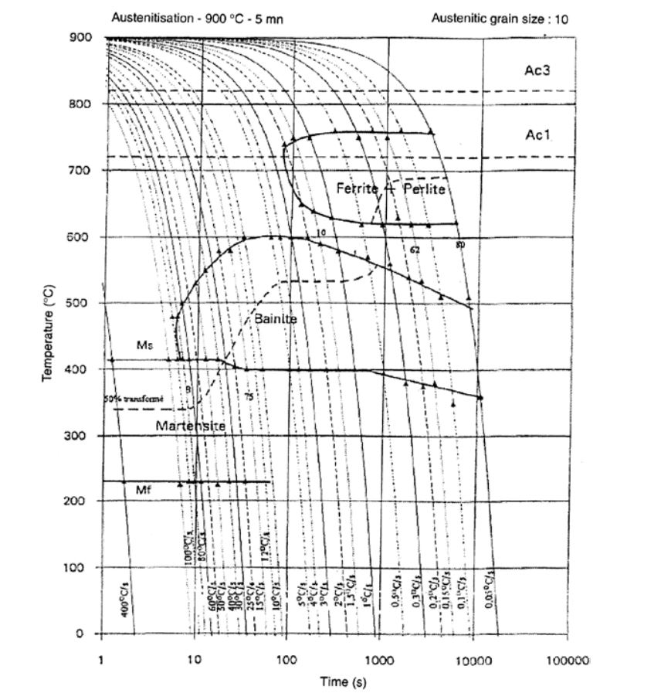
Figure 44 : 16MND5 CCT diagram from literature

The diagram simulated in Thermo-Calc is shown below (Figure 45). Again, the results are not quantitative but nevertheless give an approximation of the phases that will be formed at cooling. The curves generally seem to shift about forty degrees downwards as is observable on the martensite start or perlite start curve.

Figure 45 : Simulated 16MND5 CCT diagram on Thermo-Calc

The superposition of these two figures highlights these temperature shifts and the lack of quantification of the calculations (Figure 46). The ferrite transformation temperatures seem to be rather well calculated, but the appearance of bainite is not accurately predicted. This is a very important problem, since the 16MND5 steel is actually a bainitic steel.

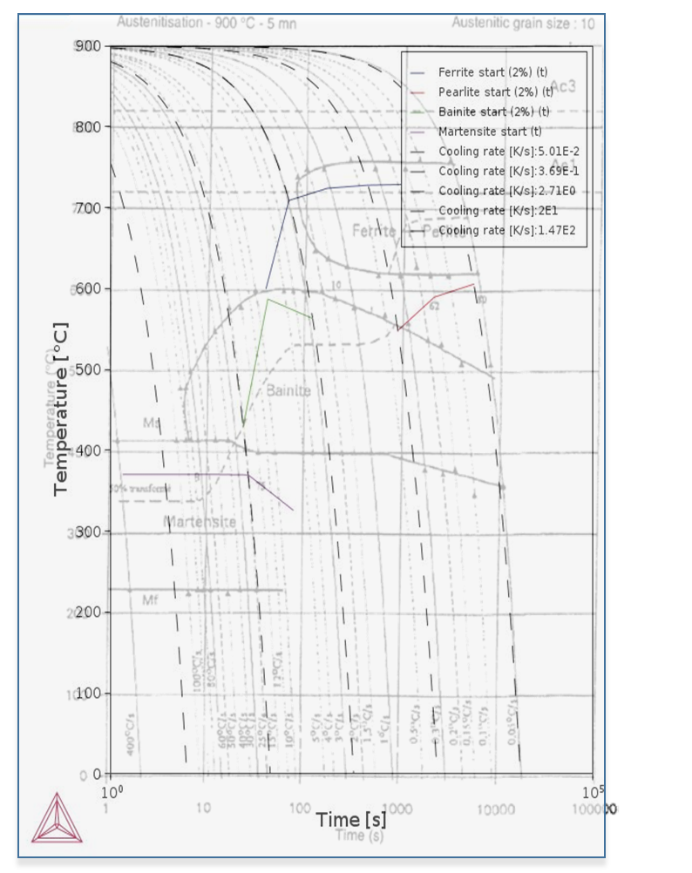
Figure 46 : Superimposition of the 16MND5 CCT diagrams from literature and simulation

2-1/4 Cr CCT diagram
Another steel grade was investigated, the 2-1/4 Cr steel, which is used in the petrochemical industry to build pressure vessels. Its chemical composition is 0.14% C – 0.46% Mn – 0.23% Si – 2.28% Cr – 0.21% Ni – 1.05% Mo. The TRC from the literature for this alloy is shown in Figure 47.
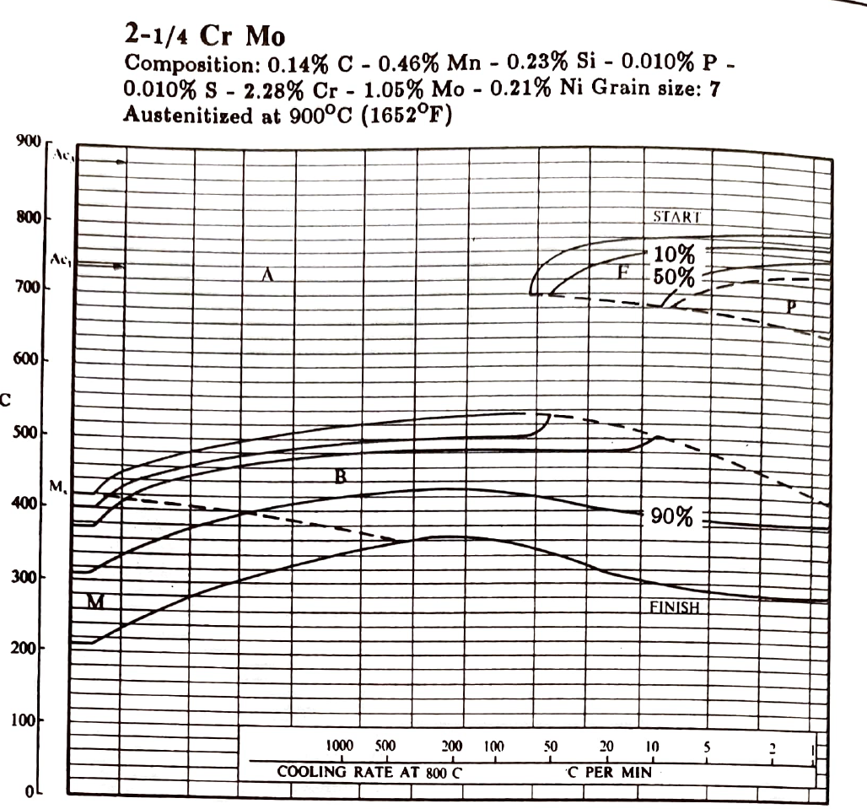
Figure 47 : 2-1/4 Cr CCT diagram from literature

The diagram simulated in Thermo-Calc shows a very large difference in the shape of the curves and the transformation temperatures (Figure 48).

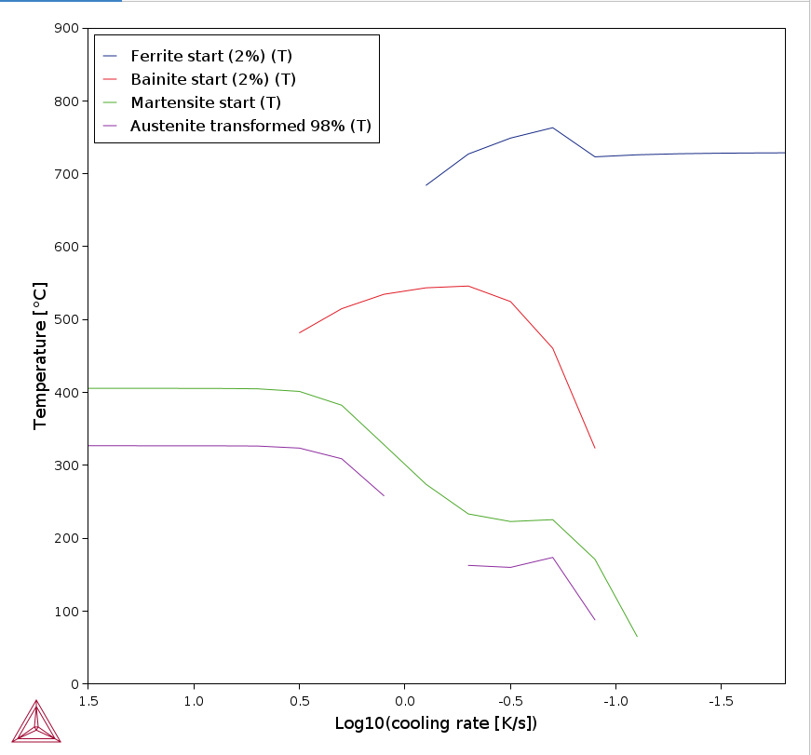
Figure 48 : Simulated 2-1/4 Cr CCT diagram on Thermo-Calc

A superimposition of the simulated and theoretical CCT diagram helps to visualize differences (Figure 49).
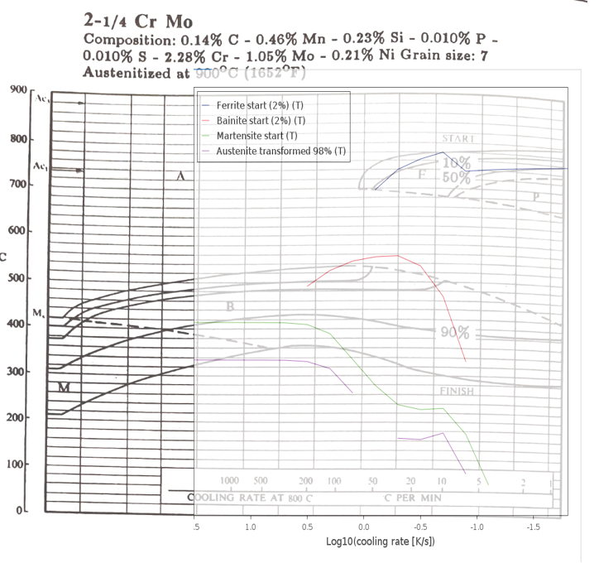
Figure 49 : Superimposition of simulated and reference CCT diagrams of 2-1/4 Cr steel

Another way of checking the accuracy or inaccuracy of the simulation diagram was to plot the evolution of phase fraction over temperature as shown in Figure 50.

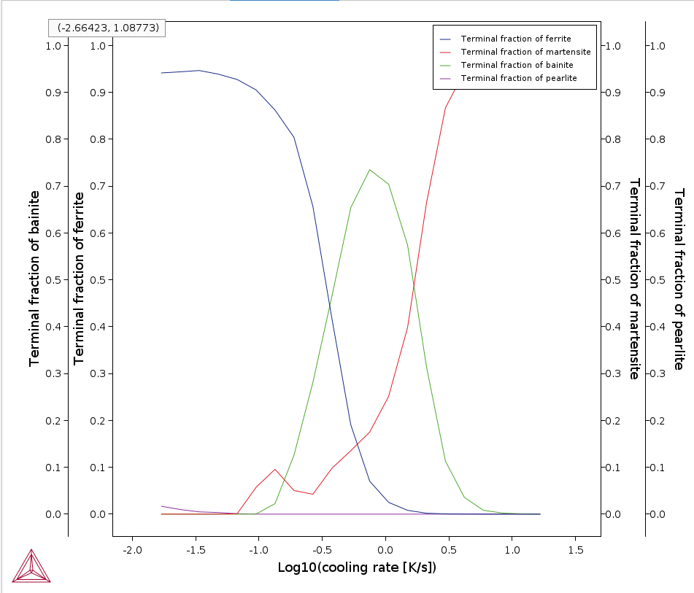
Figure 50 : Simulated evolution of phase fractions in function of cooling rates

In the literature diagram, there is a significant fraction of bainite over the entire speed range studied. However, it does not even exceed 0.05 according to the simulations. That confirms that simulated CCT diagrams plotted by Thermo-Calc are not accurate for industrial steel grades and that it needs further development to be efficient.

Conclusion
Thermo-Calc steel property module did not show sufficient accuracy to be used by Framatome. It was later confirmed that developers at Thermo-Calc Software were currently looking for ways to improve the module and Framatome will certainly be on the lookout for updates.

Thermo-Calc remains a powerful tool for metallurgy. Whether it is through thermodynamic calculations, DICTRA or its multiple addons modules, this software is a must have for any company working in the metallurgy field. The entirety of my simulation work gravitated around this software. I have learnt a lot about metallurgy through these calculations as well as how they work. I am very satisfied with the formation that my tutors gave me on Thermo-Calc over the years and I now feel confident enough to add this software to my resume and elaborate on my skills for future employers.

Conclusion to my apprenticeship
My first scientific work experience began with Framatome in September 2020 upon getting in EEIGM school for my material science engineering master’s degree. I dove in the world of metallurgy for the first time after two years of chemistry at IUT d’Orsay in a flagship French metallurgy company. The DTIMMM section concentrates some of the most qualified metallurgists and it truly was an enriching experience to be working with and getting to know them, inside or outside the workplace. It was also great to see how metallurgy could contribute to the environmental issues by being applied to the nuclear field, as it is a growing and urgent matter nowadays.
I have learnt a lot these past 3 years. I am more aware of how research and development work from within. I developed my synthesis and research skills by understanding what specifically mattered for the company within articles. I optimised my software skills on the Microsoft office pack and developed notable ones on Thermo-Calc, a major software in the field of metallurgy, that can be valued for future employers.
On a more personal note, I have matured and grown a lot. I have learnt to behave professionally with my co-workers as well as keeping a personal and pleasant personality. I have also refined my career goals thanks to Framatome, now I know a little bit more about what I want to be doing in the future and what I do not want to. With my apprenticeship contract coming to an end, I have made the choice to go back to IUT d’Orsay where I started university. This will be the opportunity for me to re-engage with chemistry, which I have missed during these years at EEIGM/Framatome. Only this time, it will be on the other side of the blackboard as I will be a teacher there for 1 year.

Industrial internship report

Context
This internship was completely independent and unrelated to Framatome’s framework because of the incapacity of finding an internship at a client’s, partner’s or affiliated research lab’s place. I was willing to find an internship myself and decided to get in touch with Ali Nazemi who was my teacher back in Winter 2020 at UQAM while being an exchange student there. Ali Nazemi replied positively to my request and on common agreement with the school and Framatome, the internship was set up. For the record, my apprenticeship contract was suspended during all this internship period.
This industrial internship was a research internship carried out in the Département de Chimie at Université du Québec à Montréal, Canada. I worked at Ali Nazemi’s lab from the 15th of May to the 04th of August 2023. It was conjointly supervised by Ali Nazemi from UQAM and Jean-Luc Six from Université de Lorraine. The internship was financed by Mitacs GlobalLink Research and provided living expenses. The subject was entitled “Production of fluorescent nano-objects, obtained by nanoprecipitation of dextrans modified by the addition of dendrons of TPE (tetraphenylethylene)”.

State of the art
So-called luminescent organic molecules have been widely used in biological fields and optoelectronics for their photophysical properties. Many studies have attempted to improve these properties because these molecules show high fluorescence in diluted medium, that however decreases as concentration of this molecule increases or when it is in the solid state (21). These fluorophores are indeed victims of an attenuation of fluorescence due to the aggregation of molecules between them. This effect has been known since 1954 and is called ACQ (aggregation-caused quenching). It is the reason why many researchers have tried to suppress this ACQ effect by modifying the chemical structure or the aggregation properties of these molecules. However, the results obtained are very limited because attenuation by aggregation is thermodynamically favoured, which is then very difficult to counter. As a result, applications of these molecules are greatly reduced.
To overcome this drawback, researchers have turned to less studied molecules, with opposite properties: AIE (aggregation-induced emission) molecules which, unlike the previously mentioned structures, exhibit increased fluorescence properties in the aggregated state. Their macromolecular homologs (AIE polymers) constitute a new family of AIE-type luminescent materials, that are even less studied than AIE molecules and still show numerous advantages. We can mention the ability of these AIE polymers to form films, synergistic effects, the good control of their morphology, etc. It is also possible to modulate structures of these polymers as desired in order to obtain a wide variety of macromolecules intended for very specific applications. Earliest works on AIE polymers date back to 2003 (20) and several fields of applications are already offered. In the optoelectronic field, these AIE materials can be used to replace the conjugated polymers currently used in standard PLEDs (Polymeric Light Emitting Diodes) which suffer from aggregation-caused quenching.
Zhao et al. (22) investigated the matter by introducing TPE, a component that will be presented below. Some AIE polymers can also be used as fluorescent sensors for which a small variation in their environment will result in a significant change in fluorescence properties. This property has been applied in the field of security, to detect explosives for example as indicated by Scherf in his work (23). In the biomedical field, materials with fluorescent properties play an important role in imaging diagnostics. The organic polymers currently used, however, suffer from the attenuation by the aggregation effect. Many research groups are therefore interested in replacing these polymers with AIE materials, allowing more sensitive and accurate imaging.
Among the AIE polymers, there exist TPE-based ones (Figure 51). We can also list AIE polymers based on distyreneanthracene (DSA), hexaphenylsilole (HPS), 1,8-napthalimide, 2,4,6-triphenylpyridine or even tetraphenylpyrazine (TPP). The TPE group can be directly included in the main chain of the polymer or as a substituent.

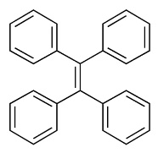
Figure 51 : Chemical Formula of the TPE (Tetraphenylethylene).

When TPE is directly in the macromolecular chain, some authors have noticed that substituting two phenyls of a TPE with one hydrogen made the material loose the AIE property. This was highlighted in Figure 52A where compounds fluorescence can be seen.
P21 and P23 fluorescence increases with concentration, unlike ACQ materials. If TPE is substituting polymer chains, the photophysical properties are impacted in another way and it is possible to modulate the quantum yield of the material (Figure 52E).

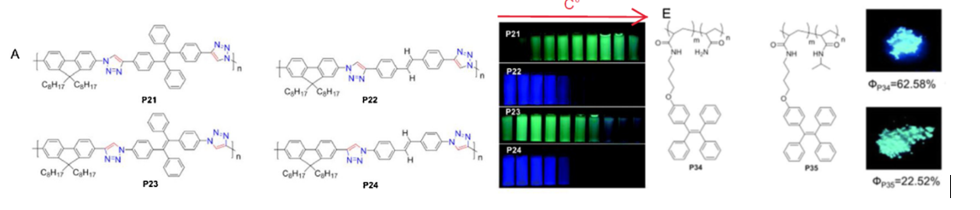
Figure 52 : Importance of TPE group location within a polymer for AIE properties. (17)

Ali Nazemi and his team investigated these AIE polymers with TPE groups (24). More precisely, they synthesized amphiphilic Janus dendrimers (Figure 53), of different generations (n), which have a hydrophilic “face” and the other hydrophobic. The synthesis of these dendrimers is based on the coupling by “click” chemistry of dendrons functionalized on the surface by TPEs and containing an azide group, with an alkyne endowed with 3 tetraethylene glycol groups (oligomer of PEGs). The Janus dendrimers are then nanoprecipitated to cause the aggregation of the TPE groups and obtain the desired AIE photophysical properties.

Figure 53 : An example of a 1st generation Janus amphiphilic dendrimer synthesized by Ali Nazemi and his team.

Yet, recent work shows that polyethylene glycol (PEG), which covers many nanostructures used in the biomedical field, currently suffers from criticism despite being approved by agencies such as the FDA. Indeed, after several years of use, some patients develop anti-PEG antibodies and the biostability of PEG remains a disadvantage. Many teams are interested in replacing PEG with substitutes such as certain polyoxazolines or polysaccharides such as dextran, of microbial origin which is biocompatible and biodegradable. Jean-Luc SIX and his team have been working for more than 20 years on derivatives combining dextran and biodegradable/biocompatible synthetic polymers, which are then formulated into nanostructures with various morphologies (core/crown nanoparticles, cylindrical micelles, nanocapsules, polymersomes) (25).
This research internship supervised by Jean-Luc SIX (France) and Ali NAZEMI (Canada) focused on obtaining dextrans modified by dendrons with a TPE surface. The derivatives obtained are amphiphilic, can be nanoprecipitated to obtain fluorescent nano-objects with AIE properties. The encapsulation of an anti-cancer drug in the synthetized nano-objects could finally open the door to a “theranostic” application.

Objectives of the internship
The objective of this internship is to produce nano-objects that are fluorescent, endowed with AIE properties, and intended for diagnostic or even theranostic applications. These nano-objects are obtained by nanoprecipitation of modified dextrans containing dendrons with a TPE (tetraphenylethylene) surface. To reach the objective, the complementarities of the French and Canadian teams are required.
These nano-objects are formulated step by step as described in Figure 54:
- Synthesis of dendrons of different generation numbers (n), surface-modified by TPE groups. These dendrons carry an azide function at their focal point and are produced in Nazemi group. (24)

- Modification of dextrans to introduce alkyne groups distributed throughout the chain. It will then be possible to produce derivatives with different amount of alkyne groups on the dextran chain, as already described by the French team (26).

- Coupling of alkyne-bearing dextrans with azide-bearing TPE-containing dendrons. This coupling, known as CuAAC (copper-catalysed alkyne-azide cycloaddition), is part of the click chemistry reactions whose interest for the scientific community has been crowned by the Nobel Prize in Chemistry 2022. These compounds will be amphiphilic due to the hydrophilicity of dextran, and the hydrophobicity of TPEs. This coupling, easy to achieve, has already been implemented by the 2 teams. It will be possible to vary the generation of dendrimers grafted onto the dextran, as well as the grafting rate. A panel of amphiphilic compounds will thus be obtained after step 3.

- Nanoprecipitation of these amphiphilic compounds and characterization of the fluorescence properties. The AIE properties will be investigated, these properties will be related to the macromolecular parameters of the synthetized dextran derivatives.

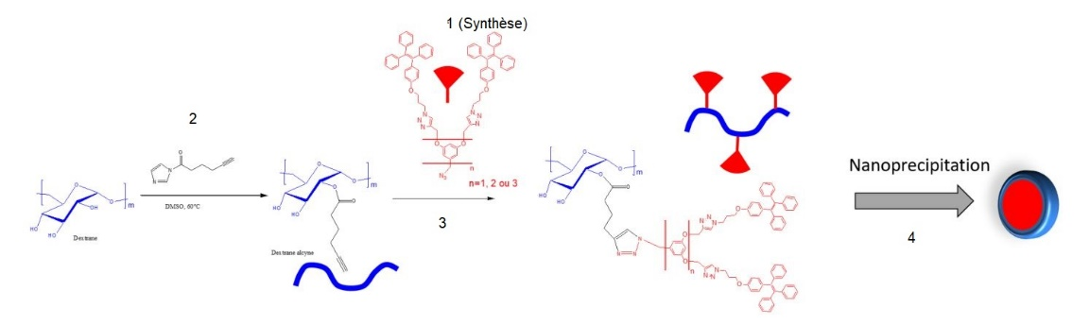
Figure 54 : Schematic overview of the project

Parts 1 and 2 were already completed by Ali Nazemi’s and Jean-Luc Six’s teams, respectively. My involvement in the project started at step 3, which was the click reaction of the alkyne-containing dextrans with the azide-containing TPE derivative. Upon receiving the samples from France, the reactions were carried out as follows.

Synthesis and characterisation
The dextrans alkyne and the TPE azide derivatives were coupled via a famous click reaction called the CuAAC. This reaction is very well documented and allows for high yield, low cost, and environmentally friendly chemistry. Ali NAZEMI’s group has already used this reaction many times in the past meaning they have come around to mastering it. The reaction general mechanism is shown in Figure 55. This is the concerted bimetallic mechanism involving two copper atoms.
The CuAAC reaction is initiated with the reduction of Cu^{II} salts to form Cu^{I} active species, which then become part of the catalytic cycle. This reduction can be achieved by introducing a reducing agent, such as sodium ascorbate. The active catalytic cycle commences by a Cu^{I}-alkynyl complex coordinating with a second Cu^{I} complex. A notable aspect of this mechanism is that the azide cycloaddition to the resulting dicopper species occurs in two distinct steps, involving the subsequent reactions: 1) azide coordination to the dicopper core, leading to the initial C–N bond formation within a six-membered metallacycle, followed by 2) intramolecular C–N bond creation, resulting in the formation of the triazolyl-CuI intermediate and the detachment of one of the two copper atoms. Finally, in the concluding stage, a proton shift from the alkyne to the triazolyl ligand enables the regeneration of the alkynyl CuI complex and the liberation of the 1,4-triazole product (27).
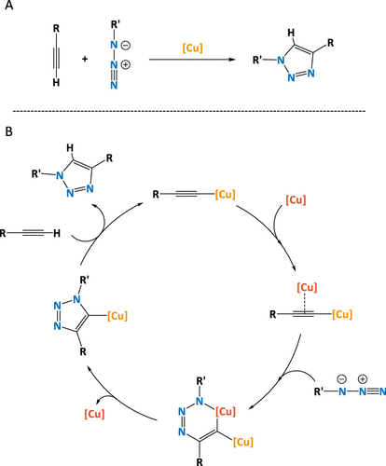
Figure 55 : Copper azide alkyne cycloaddition mechanism.

To set up the reaction, 200 mg of dextran alkyne and 51 mg of TPE G0 derivative were dissolved in a stirred solution of 4 mL DMSO and 1 mL nanopure water. Then, 1.2 equiv of sodium ascorbate was weighed and transferred to the solution. Lastly, 0.7 equiv of copper sulfate was added to the round bottom flask and left to react for 24 hours.
5% alkylated dextrans and 15% alkylated dextrans were sent from France. The reactions and characterisations were optimised for the 15% alkylated dextran since this is case that is expected to have more effect for the characterisations, due to higher grafting sites.

G0 TPE derivative coupling with dextran
Figure 56 shows the reaction scheme for our G0 TPE derivative, as described previously. After being left to react for 24 hours, the product was precipitated twice in a solution of isopropanol/DMSO (50/1 v/v) and then centrifugated, separated out and dried.
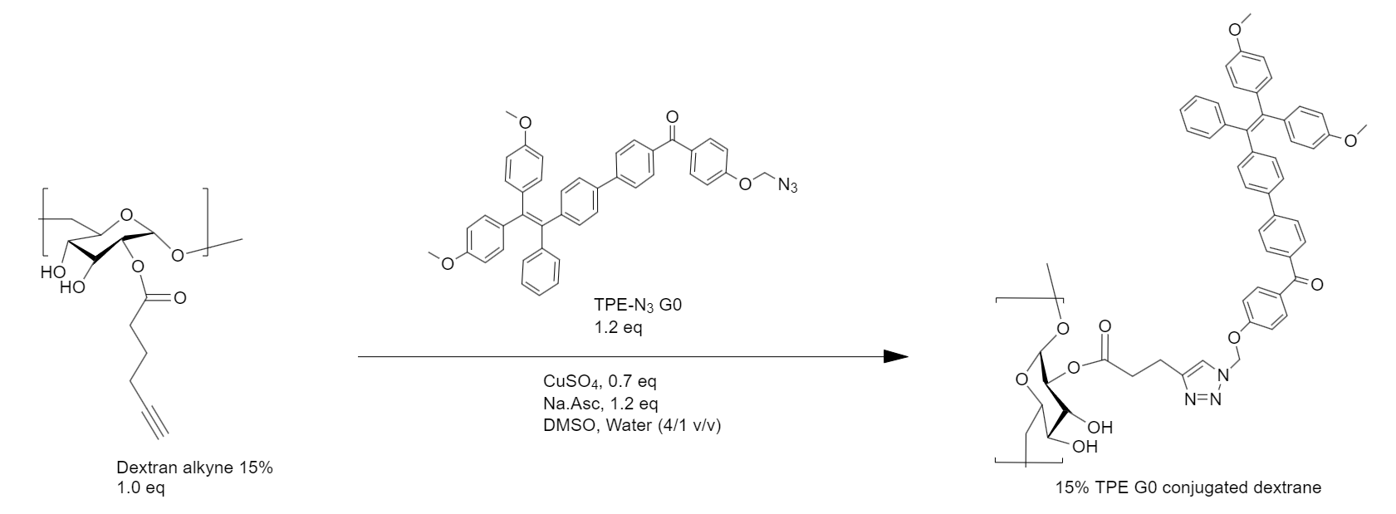
Figure 56 : Reaction scheme for the coupling of dextran alkyne 15% with TPE-N₃ derivative (G0).

The first characterisation carried out was the infrared spectrum with the ATR spectroscopy. The goal with the analysis was to determine if the reaction was complete, meaning there should not be any alkyne group left, and if the purification had worked, meaning there should not be unreacted azide groups from the TPE derivative.
In Figure 57, the full line shows the IR spectrum for the reaction product. The light dotted line shows the IR spectrum for the TPE-N₃ G0 derivative and the dash line corresponds to the 15% alkylated dextran. Circled in blue is the azide sharp signal from three nitrogen of the azide group and circled in red, the alkyne carbon-carbon triple bond elongation. These two peaks are around 2100 cm⁻¹, meaning that any signal in this area on the product spectra would mean incomplete reaction or purification. In that case, the reaction was complete and the purification a success.

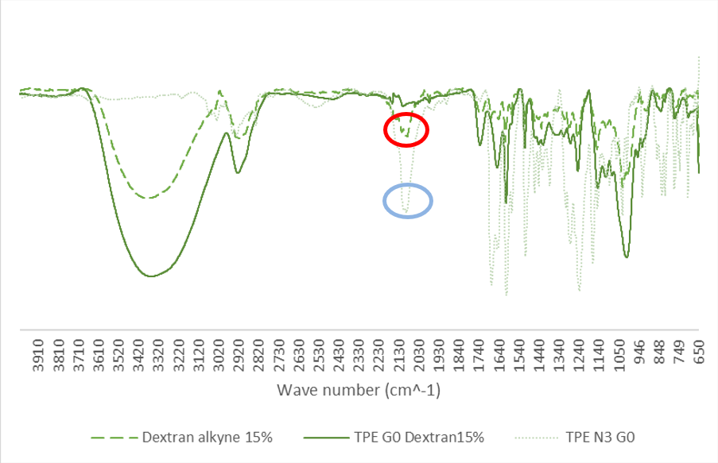
Figure 57 : IR spectrum (ATR) of the TPE G0 grafted dextran (full line), the TPE-N₃ G0 derivative (dotted line) as well as the 15% alkylated dextran (dash line)

To make sure the TPE groups were well grafted onto the polymer chain, NMR spectroscopy was carried out. At about 7-8 ppm, we expect to see a multiplet coming from aromatic hydrogens. That is the case here (Figure 58) and that means that the grafting was successful.

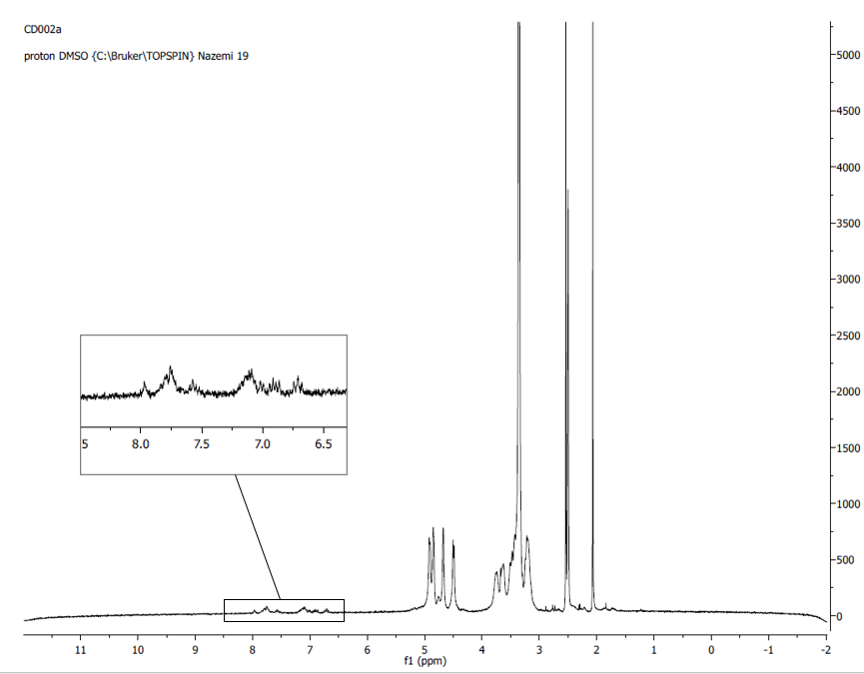
Figure 58 : NMR spectrum of the TPE(G0)-grafted dextran

We then proceeded to the UV absorbance characterisation. A UV lamp shines light through the sample and the grafted TPE will absorb at a certain wavelength. Figure 59 shows the absorbance peaks for 15% and 5% grafted dextrans. The peaks are at about the same wavelength for both products (350 nm), the difference being the absorbance intensity. The 15% grafted dextran will show more absorbance because it bears more fluorescent TPE groups at the same polymer concentration. The second absorbance peaks at 300nm for both curves are from the dendron backbone structure which is not highly conjugated.
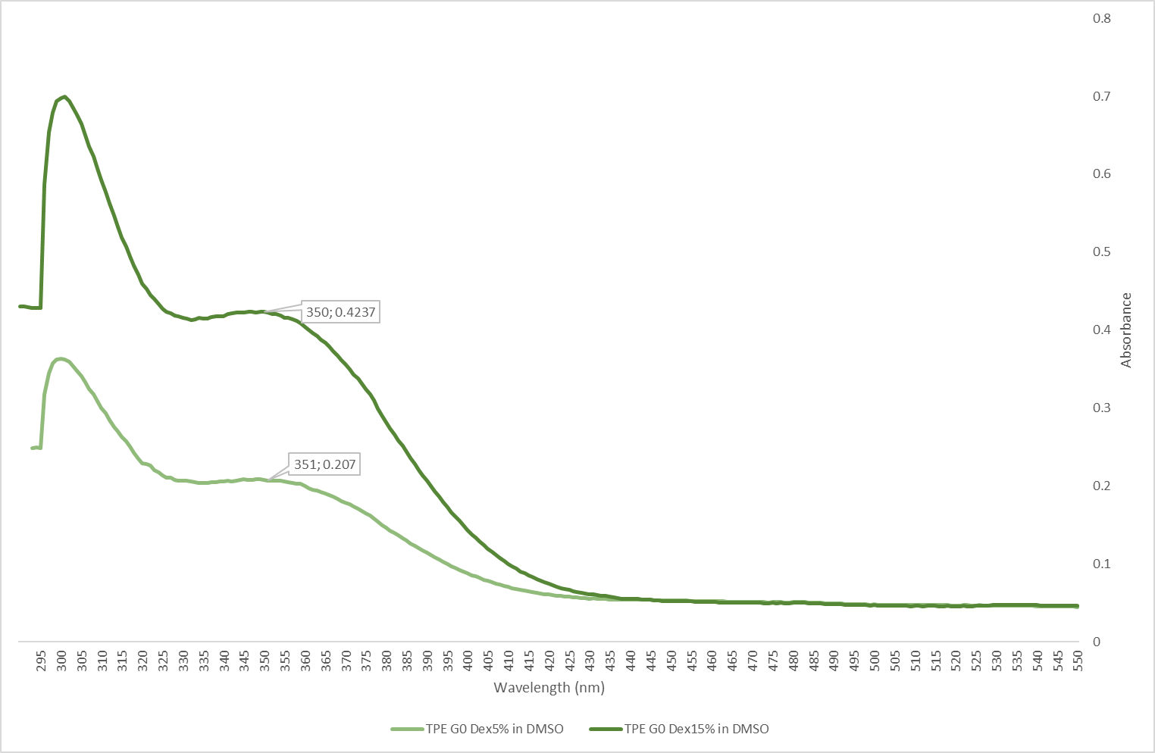
Figure 59 : UV absorbance spectra of the 5% TPE(G0)-grafted dextran and the 15% TPE(G0)-grafted dextran.

The fluorescence behaviour was also investigated, and the absorbance peak determined before, 351 nm, is the excitation wavelength for the spectrofluorometer. A 5 mg/mL solution of the reaction product in filtered DMSO was made, and a sequence of analysis was planned. 60 µL of that solution is transferred to a quartz cell with 3 mL DMSO. The idea is to repeat that operation 10 times and to increase by 10% the water content until the last measurement only contains nano-pure water and the product. The aim of this characterisation technique was to observe an increase in fluorescence intensity with the increase of water content, symbolic of the aggregation induced emission effect.
Figure 60 below reports the results: we can see that the maximum intensity at about 520 nm is reached when the media is completely aqueous. This means that the product was at its most aggregated state with 100% water content.

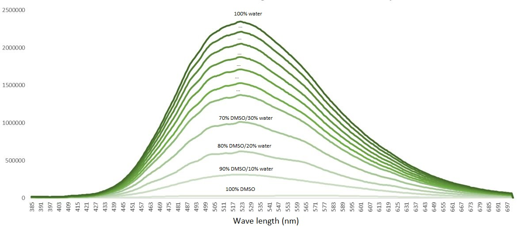
Figure 60 : Evolution of the fluorescence behaviour of the TPE(G0)-grafted dextran with increasing water content.

After the fluorescence assessment, the next step was to analyse the structures naturally present in DMSO before self-assembly. We used DLS, Dynamic Light Scattering, to observe the size of these structures. Figure 61 shows the size distribution graphs in number and Figure 62 the distribution in volume. The measurements were not repeatable nor was it possible to draw conclusions from them because the size classes were expected to range from 1 to 10 nm. Here they ranged from 8nm to 78nm on the number distribution graph and up until 6,438 nm for the volume distribution. These results demonstrate that the polymer is not fully in its dissolved state in DMSO and potentially undergoes self-assembly in this solvent.

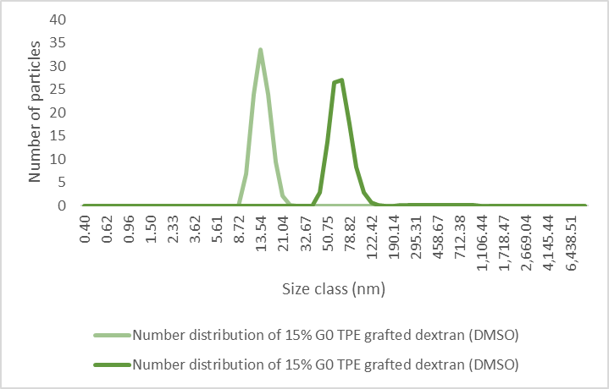
Figure 61 : Number distribution of particles sizes for the TPE(G0)-grafted dextran before self-assembly.

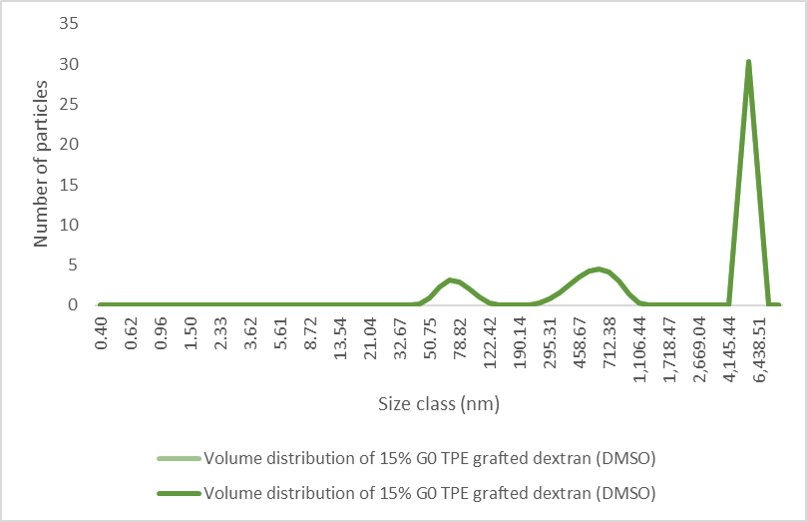
Figure 62 : Volume distribution of particles sizes for the TPE G0 grafted dextran before self-assembly.

TPE dendron (G1) coupling with dextrans
The TPE-functionalized G1 dendron with an azide functionality in its focal point was also coupled to the dextran using the same reaction scheme, shown below in Figure 63. The same numbers of equivalents were used for about 50mg of 15% alkylated dextran. The reaction time was 48 h plus an additional 48 h because the first IR spectra exhibited non negligeable azide/alkyne signal. The reaction was resubjected with more TPE-N₃ G1 dendron and left to stir for an additional 48 h. The final product was precipitated twice with the isopropanol/DMSO (50/1) solution, centrifugated and dried. The product was then dialysed against DMF using a membrane for 24 hours.

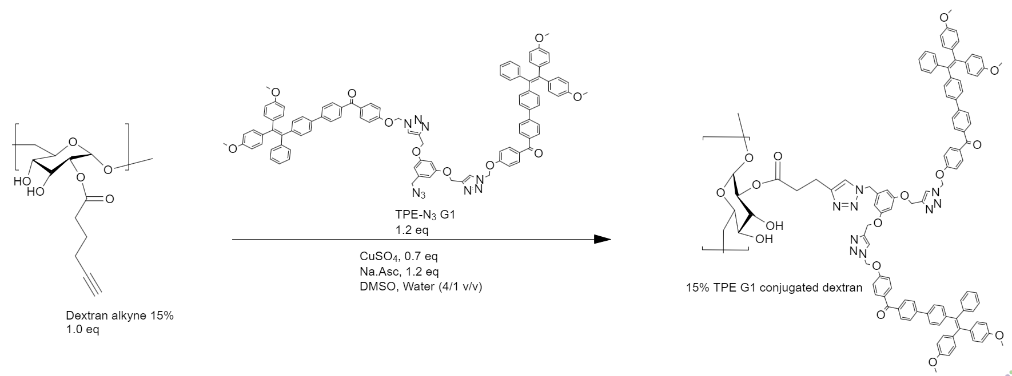
Figure 63 : Reaction scheme for the coupling of dextran alkyne 15% with G1-TPE-N₃ dendron.

The infrared spectrum of the 15% G1 TPE grafted dextran is shown below in Figure 64. No significative traces of azide or alkyne were found, the reaction was considered complete and the purification a success.

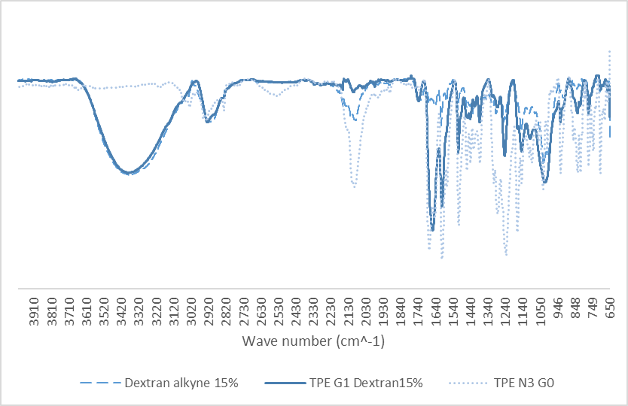
Figure 64 : IR spectrum (ATR) of the TPE G1 dendron-grafted dextran (full line), the TPE-N₃ G0 dendron (dotted line) as well as the 15% alkylated dextran (dash line)

The NMR spectrum in Figure 65 showed some aromatic hydrogen signal despite the weak signal, meaning they were correctly grafted onto the polymer.

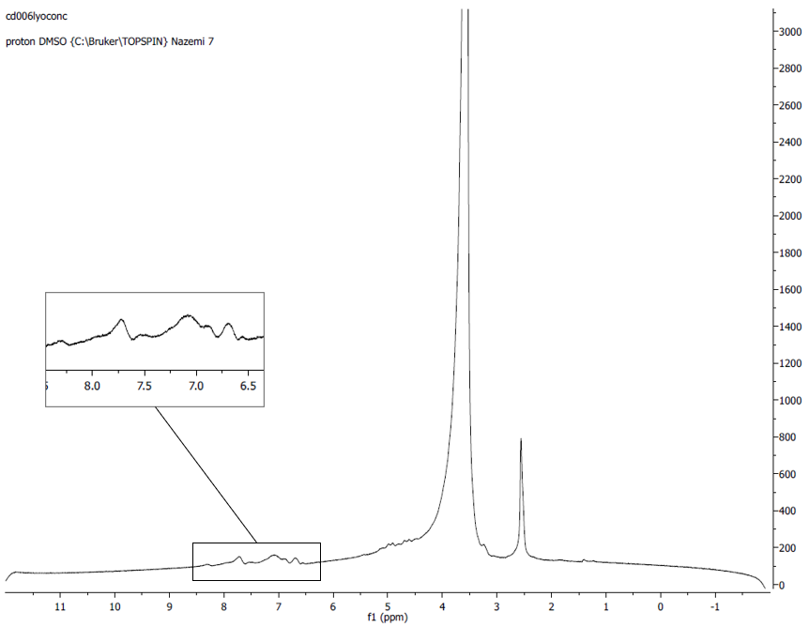
Figure 65 : NMR spectrum of the TPE G1 grafted dextran

The UV absorbance peak for this product turned out to be the same as for the TPE G0 grafted dextran, which is 350 nm, as shown in Figure 66. The second absorbance peak at 300nm is from the dendron backbone structure which is not highly conjugated.

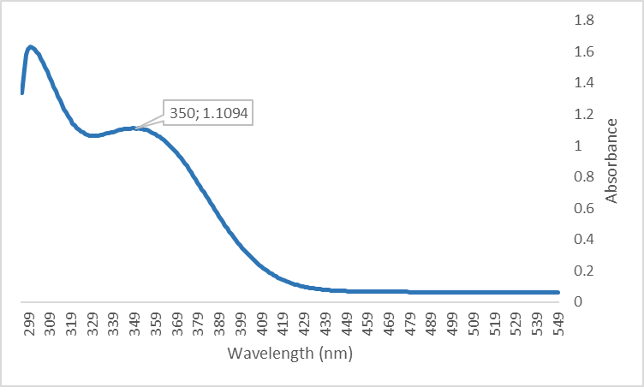
Figure 66 : UV absorbance spectrum the 15% TPE G1 grafted dextran.

For the fluorescence behaviour however, it has shown some differences (Figure 67). An identical solution of 5 mg/mL in DMSO of the TPE G1 grafted product was made and the same water content increasing protocol was used. First, the maximum fluorescence intensity is not found for a 100% aqueous medium but for a 30% water in DMSO solution (v/v). Moreover, the emission wavelength seems to be fluctuating more widely around 520 nm than for the TPE G0 derivative. The reason for that may be that the grafted G1 dendrimer has twice more TPE than G0, meaning more steric effect and interactions possibly interfering with π-π stacking or longer time to reach the stereoconfiguration equilibrium.

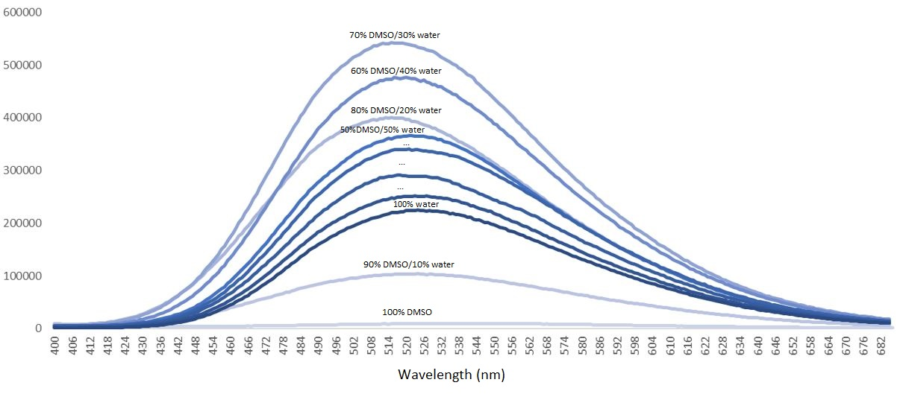
Figure 67 : Evolution of the fluorescence behaviour of the TPE G1 grafted dextran with increasing water content.

Finally, the DLS showed better results with repeatable measurements and coherent class sizes of about 5-10 nm for both number (Figure 68) and volume distribution (Figure 69). This class size is expected because dextrans are known to assemble in about 1-5 nm structures in DMSO and the grafted dendrimer possibly adds size and changes the structure.

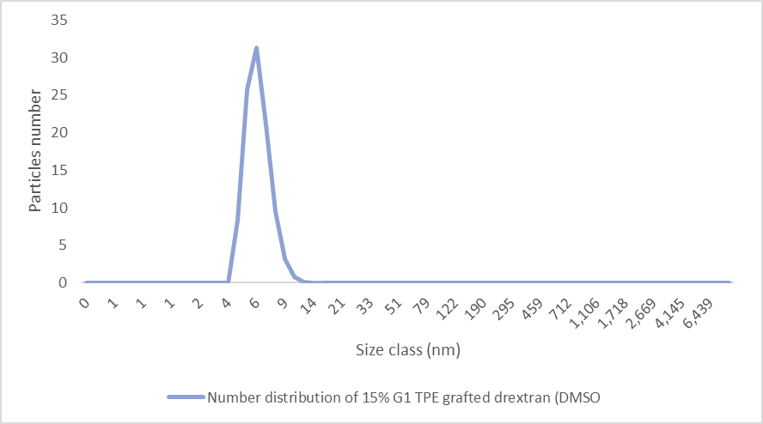
Figure 68 : Distribution of particles sizes for the TPE G1 grafted dextran before self-assembly (number)

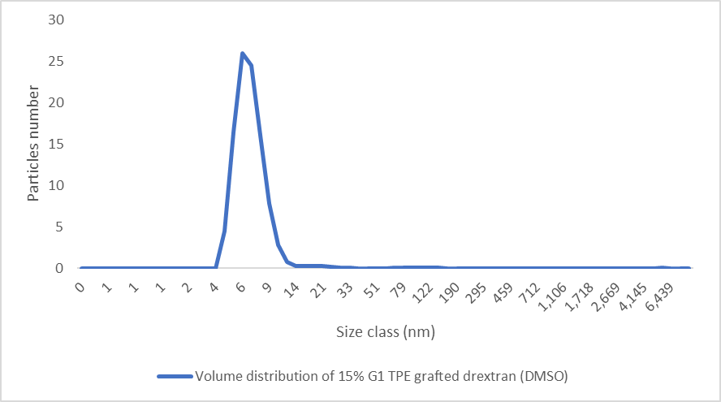
Figure 69 : Distribution of particles sizes for the TPE G1 grafted dextran before self-assembly (volume)

Conclusion & perspectives
This project dealt with the grafting of TPE-containing dendrimers onto alkylated dextrans. We were able to synthetise and characterise G1 and G0 TPE dendrimer grafted on dextrans. IR, NMR, DLS, UV and fluorescence analysis have been carried out. For G0 TPE derivative, the reaction was complete after 24 hours and the purification step was a success and showed good preliminary results.
The 15% G1 TPE grafted dextran showed satisfying results which are different from those obtained with G0. The reaction was 4 times longer due to slow kinetics caused by steric effects and a dialysis was needed to better purify the product, after resubjecting
This project marks the start of a collaboration between Jean Luc SIX’s lab and Ali NAZEMI’s team between France and Canada. This is also the first time that the Canadian team has been working with sugars/polysaccharides, which revealed to be complex to synthetise because of the dextrans overall slow kinetics.
Synthesising and characterising the G2 TPE derivative grafted onto dextrans is the next step of this project, as well as assessing cytotoxicity and self-assembly properties of these TPE grafted materials.
On a more personal note, this internship allowed me to get back into chemistry accompanied by Ali NAZEMI who was my teacher about 3 years ago during my first international exchange. It was a really enriching experience to be working again in a chemistry lab and was able to learn again the basics, which will help later if I want to motivate a career in polymer chemistry.

